ANNUAL REPORT

2018–19

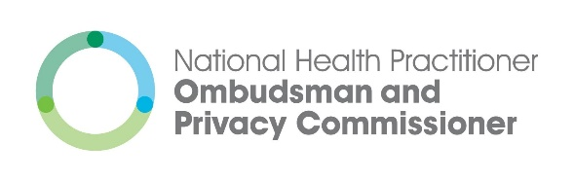

# Acknowledgement of Country

The office of the National Health Practitioner Ombudsman and Privacy Commissioner acknowledges the Wurundjeri people as the traditional custodians of the land on which our office is located. We would also like to acknowledge the Aboriginal and Torres Strait Islander peoples, who are the traditional custodians of the lands where our services extend.

We pay our respects to Elders, past, present and emerging across Australia and to those who may be reading this report. We value and are committed to honouring Aboriginal and Torres Strait Islander peoples’ rich contribution and unique and continuing connection to the land, water and community.

To receive this publication in an accessible format phone 1300 795 265, using the National Relay Service 13 36 77 if required, or email our communications team [media@nhpopc.gov.au](mailto:media@nhpopc.gov.au).

Authorised and published by the National Health Practitioner Ombudsman and Privacy Commissioner, 2 Lonsdale Street, Melbourne.

© National Health Practitioner Ombudsman and Privacy Commissioner, September, 2019.

ISSN 2205-4898 (Print)   
ISSN 2205-4901 (Online)

Available from the NHPOPC website [www.nhpopc.gov.au](http://www.nhpopc.gov.au). Printed by Doculink Australia, Port Melbourne (1907387).

# Our year in numbers

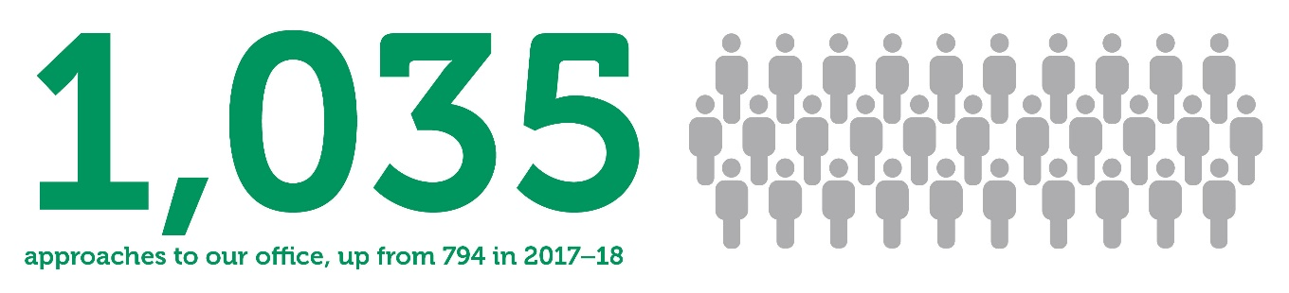

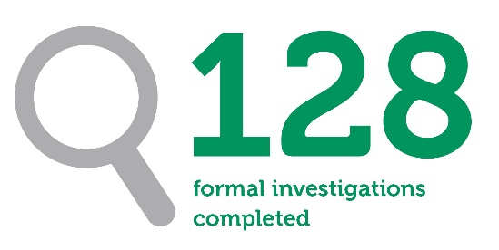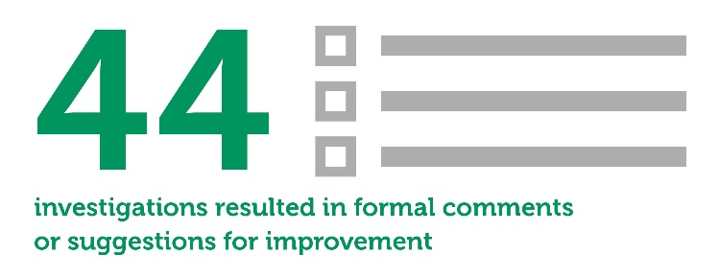



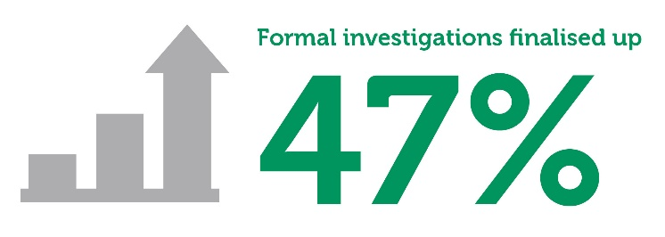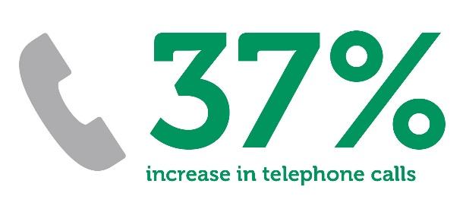

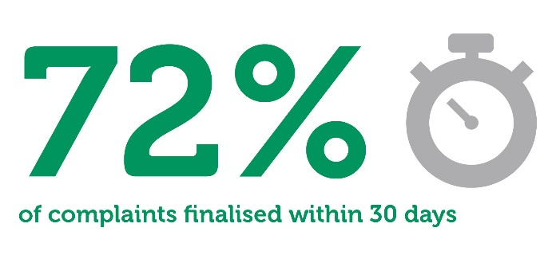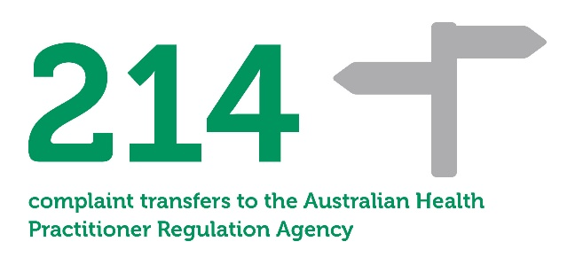



# Letter of transmittal

The Hon. Roger Cook MLA

Chair

COAG Health Council

PO Box 3410

Rundle Mall

Adelaide SA 5000

Dear Minister,

I am pleased to present you with the National Health Practitioner Ombudsman and Privacy Commissioner’s annual report for the period 1 July 2018 to 30 June 2019.

The report has been prepared in accordance with section 29 of the Health Practitioner Regulation National Law Regulation 2018.

I am satisfied that the office of the National Health Practitioner Ombudsman and Privacy Commissioner’s financial and governance processes meet our specific needs and comply with the requirements of section 28 of the Health Practitioner Regulation National Law Regulation 2018.

Yours sincerely,

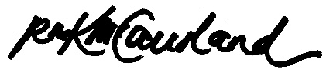

Richelle McCausland

National Health Practitioner Ombudsman and Privacy Commissioner

# Message from the Ombudsman and Commissioner

It has been a privilege to influence improvements in the National Registration and Accreditation Scheme (the National Scheme) in my second year as the National Health Practitioner Ombudsman and Privacy Commissioner.

In Swedish, ‘Ombudsman’ generally translates to mean a representative or protector of citizens. This is a role I do not take lightly, and I am proud to join Ombudsmen across the world providing free, impartial and independent services to diverse communities.

Each complaint my office receives is important. We strive not only to resolve individual concerns but also to recognise the potential of each complaint to provide invaluable information about systemic issues that may also be affecting others.

## My highlights

This year, my office received a record 1,035 approaches from members of the public and health practitioners. This represents a 30 per cent increase compared with last year (794) and is the fourth consecutive year we have seen large increases in the number of concerns shared with us.

My team rose energetically to this challenge and worked diligently to assess and investigate complaints in a fair and empathetic manner.

I am proud to share that, despite the significant increase in workload, we successfully finalised more matters this year than we received.

Most importantly, we provided meaningful outcomes to individual complainants and assisted with bringing about significant improvements in the administrative actions of the Australian Health Practitioner Regulation Agency (AHPRA) and the 15 National Boards.

This financial year we:

* finalised 128 investigations, which resulted in 44 formal comments or suggestions for improvement being made to AHPRA and the National Boards
* worked collaboratively with AHPRA and the National Boards to identify and address systemic concerns

launched an own motion investigation (at the request of AHPRA) into the critical issue of safeguarding the confidentiality of people who make notifications about health practitioners.

## Looking forward

We begin the new financial year ready to address all concerns brought to our attention. Our ability to manage the increasing workload will be bolstered by procuring a new electronic complaint management system and continuing to support staff by investing in training and team-building opportunities.

In the new financial year, I look forward to focusing on our engagement with the missing voices from our complaints service through the implementation of a comprehensive stakeholder engagement plan. I am passionate about making sure our services are available to diverse community groups and those health practitioners who are currently under-represented in our complaints data.

I am also eager to continue working collaboratively with AHPRA and the National Boards to resolve areas of concern. I look forward to trialling a new ‘early resolution’ complaint-handling model with the aim of successfully resolving more complaints without the need for my office to conduct full investigations.

I would like to give my heartfelt thanks to my dedicated team, who work tirelessly to address a diverse range of often complex concerns with empathy and enthusiasm. I also thank the COAG Health Council Secretariat and the Secretary and staff of the Victorian Department of Health and Human Services for providing essential support to my office.

I would like to thank AHPRA’s senior leadership team for their continued commitment to addressing complaints and systemic issues raised by my office.

It is my sincere pleasure to share our annual report with you, along with some of the stories of people we have worked with this year to make a difference.

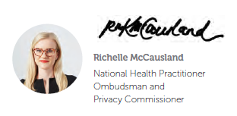

# Contents page

Acknowledgement of Country 2

Our year in numbers 3

Letter of transmittal 4

Message from the Ombudsman and Commissioner 5

Contents page 6

About our office 8

Our team 11

Contact with our office 13

Finalised complaints 14

Our complaint handling work in numbers 15

Who complaints were about 16

Where complaints came from 17

Common complaint themes 19

Freedom of information 20

Understanding how the complaints process works 22

Our service charter 23

Resolving a complaint through investigation: Haruto’s story 24

Transferring a complaint to AHPRA: Gabriel’s story 25

Outcomes: complaints about the handling of notifications 27

Outcomes: complaints about the handling of registration matters 30

Outcomes: complaints about privacy matters 33

Creating systemic change 34

Own motion investigation 36

Working with AHPRA 39

Working with the National Boards 42

Community engagement 43

Submissions 45

Our approach to governance and accountability 47

Our response to operational challenges 48

Our strategic priorities 49

Financial statement 50

Our vision is   
a fair and trusted   
health practitioner   
regulation scheme

# About our office

Our office is dedicated to ensuring the National Registration and Accreditation Scheme (National Scheme) is responsive and accountable.

## Our role

Our primary role is to provide oversight of the Australian Health Practitioner Regulation Agency (AHPRA) and the 15 National Boards[1](see Figure 1). This is an important role because of the significant work AHPRA and the National Boards do to regulate the health professions in Australia.

**Figure 1: Our role in the National Scheme**

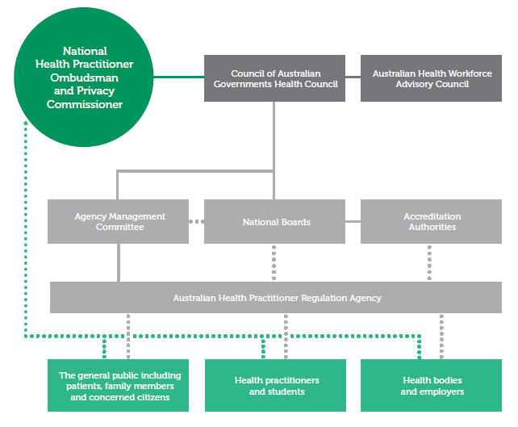

## What we do

### Complaint resolution

Our office provides a free, impartial and independent complaint-handling service for the public and health practitioners.

We hear concerns raised about the administrative actions of AHPRA and the National Boards in relation to:

* notifications about registered health practitioners
* registration matters
* handling of personal information

freedom of information (FOI) requests.

We listen to concerns and carefully consider the most appropriate way to resolve the matter. We may:

* decide to investigate
* transfer the complaint directly to AHPRA for a response (a ‘warm transfer’)

decide not to investigate (for example, if the matter is more than 12 months old or would more appropriately be dealt with by a court or tribunal).

When we investigate a complaint, we review the available evidence to determine whether the relevant administrative actions:

* were lawful and reasonable
* were consistent with relevant policies   
  and procedures.

After completing an investigation, we may:

* provide (or suggest that AHPRA or a National Board provide) a better explanation of the decision or action to the person who made the complaint
* speed up the processing of a delayed matter
* suggest that an apology be offered to the person who made the complaint
* suggest that a process or policy be reviewed or changed by AHPRA or a National Board
* suggest that a decision be reconsidered by AHPRA or a National Board

decide that the handling of the matter was reasonable and take no further action.

### Further investigations

The Ombudsman and Commissioner can also conduct ‘own motion’ investigations. This means we can investigate an issue of interest even if we do not receive a complaint specifically about that issue.

The main purpose of an own motion investigation is to identify areas for improvement in the National Scheme.

### Systemic improvements

An important part of our role is working collaboratively with AHPRA and the National Boards to:

* identify and address systemic issues and problems

ensure administrative processes are reasonable and transparent.

### Engagement

We also provide insight into issues that have been raised by AHPRA, the National Boards or other organisations whose work could influence how the National Scheme operates.

We engage with community members and health practitioners to raise the profile of our services.

The key areas of our work are shown in Figure 2.

**Figure 2: Our key areas of work**

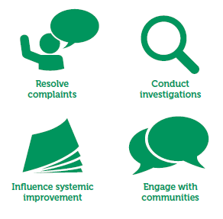

Dr Mateo’s Story

Dr Mateo contacted our office to voice his concerns that AHPRA and the Medical Board of Australia failed to identify that notifications had been made about him vexatiously. Dr Mateo explained that this led the Medical Board to inappropriately take immediate action and place supervision conditions on his registration.

The supervision conditions remained on Dr Mateo’s registration for almost two years, despite him making many complaints to AHPRA about the length of time it was taking to finalise the investigation into the matters raised in the notifications.

Dr Mateo told us that this delay caused him professional humiliation, financial hardship and emotional distress. In particular, he explained that the supervision conditions on his registration resulted in his then-employer terminating his employment.

After AHPRA concluded its investigation, the Medical Board decided to take no further action in relation to the notifications made about Dr Mateo. Many of the issues raised in the notifications were found to be lacking tangible evidence and were unable to be substantiated.

The Medical Board also decided to raise notifications about the practitioners who notified about Dr Mateo because it was concerned that the possibly vexatious nature of the notifications could be evidence of unprofessional conduct.

Our office listened to Dr Mateo’s complaint and opened an investigation. Our investigation identified several concerns regarding AHPRA’s handling of the notifications about Dr Mateo. These included:

* significant delays in AHPRA’s investigation, which particularly affected Dr Mateo because of the immediate action conditions that remained on his registration during the investigation
* AHPRA’s failure to adequately identify all concerns in the notifications at the beginning of the process, which resulted in delays when the issues for investigation were later re-scoped

inadequacies in AHPRA’s IT systems, which resulted in the Medical Board not being provided with Dr Mateo’s full response when the Medical Board proposed taking immediate action.

At our suggestion, AHPRA wrote to Dr Mateo to apologise for his negative experience and to advise of the steps it had taken to improve its handling of notifications. The Chief Executive Officer of AHPRA also spoke personally to Dr Mateo to discuss his concerns.

As a result of Dr Mateo’s complaint, AHPRA agreed to:

* implement a process where all conditions or suspensions on a practitioner’s registration resulting from immediate action are reviewed every six months while an investigation remains ongoing

take steps to address the IT system issue that meant the Medical Board was not provided with Dr Mateo’s full response to the proposed decision to take immediate action.

The implementation of the process for six-monthly reviews of conditions or suspensions on a practitioner’s registration resulting from immediate action is expected to begin in early 2020.

Dr Mateo was grateful for the assistance provided by our office and highlighted the patience, compassion and professionalism shown towards him during the handling of his complaint.[2]

# Our team

## The Ombudsman and Commissioner

The Ombudsman and Commissioner is an independent statutory officer appointed by the Council of Australian Governments (COAG) Health Council.

The current Ombudsman and Commissioner, Richelle McCausland, was appointed to the role in May 2018 for a term of three years.

Ms McCausland is supported by a small team of 13 highly skilled professionals. Ms McCausland oversees all staff activities. The office is divided into three operational arms to effectively manage our work: the Investigation Unit, the Policy and Strategy Unit and the Business Services Unit.

## Investigation Unit

Our investigators are primarily from a legal background and have extensive experience working across the health and legal sectors. Our investigators are all trained in, and dedicated to, communicating in a professional and empathetic way.

In June 2019 our Investigation Unit welcomed a new FOI review officer. This role was created in response to additional FOI review powers given by law to the Ombudsman and Commissioner.

Our Investigation Unit is also supported by an administration officer.

## Policy and Strategy Unit

Our Policy and Strategy Unit works to ensure our policies and procedures adhere to best practice.

In June 2019 we welcomed a new communications officer dedicated to continuing our stakeholder engagement and communication with the public and health practitioners.

## Business Services Unit

Our Business Services Unit keeps our office running efficiently by developing and managing our governance and financial and business services.

“I’ve worked as a senior member of the office of the National Health Practitioner Ombudsman and Privacy Commissioner for over two years. Our team has a rare opportunity to work with people from all walks of life on many different process and policy issues.

Many of the people who contact our office have been through really tough situations involving their health or their careers. It is really rewarding to work with each person and get meaningful outcomes for them.

It is also great to work collaboratively with others to ensure our health practitioner regulation system works fairly and effectively for everyone.”

– Chris, Team Leader



Our independent   
complaints service is free and open to all to ensure our health practitioner   
regulation system is   
accountable and fair

# Contact with our office

This financial year our staff provided professional and empathetic services to a record number of people.

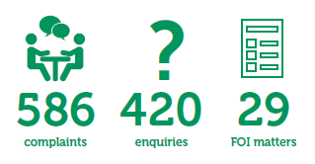

Our office received 1,035 approaches regarding a range of different matters. This represents a 30 per cent increase compared with 2017–18 (see Figure 3).

As in previous years, we believe this increase in the number of people approaching us is due to several factors including:

* continued growth in the number of registered health practitioners
* a spike in the number of notifications made to AHPRA about registered health practitioners

increased awareness about the role of our office and the ability to make complaints about AHPRA and the National Boards.

**Figure 3: Approaches we received between 2016–17 and 2018–19**

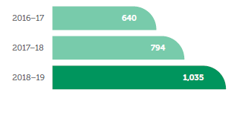

## Complaints

Of the 1,035 approaches we received this financial year, 586 related to concerns about the administrative actions of AHPRA and the National Boards. We call these approaches ‘complaints’.

Our office generally receives complaints in four main categories:

* the handling of a notification (52 per cent)
* the handling of a registration-related matter (40 per cent)
* the handling of a request for documents under FOI legislation (3 per cent)

a breach of privacy (3 per cent) (see Figure 4).

**Figure 4: Types of complaints in 2018-19**

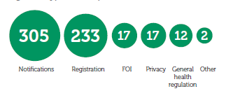

## Enquiries

Our office received 420 enquiries in 2018–19.

The majority of these approaches (326) related to concerns we were not able by law to consider. We also received 37 requests for general information about our office, five media requests and 52 enquiries about other matters.

We call these contacts ‘enquiries’ because they are outside our core complaint-handling activities.

We always do our best to refer people to the appropriate service to address their concerns if we are unable to assist them.

## FOI matters

In 2018–19 our office began a new role in relation to the oversight and review of FOI decisions made by AHPRA, its Management Committee and the National Boards.

We received 29 unique contacts in relation to FOI matter

# Finalised complaints

We are proud to have finalised more complaints than we received in 2018–19. This is because we finalised a small number of complaints carried over from the previous financial year.

Our team’s efficient and empathetic handling of complaints has resulted in more people receiving meaningful outcomes from our office than ever before.

## Complaints we investigated and resolved

During 2018–19, 21 per cent (128) of the 600 complaints we finalised were investigated.

Generally, investigations resulted in three outcomes:

* providing a further explanation to the complainant
* providing formal comments and/or suggestions for improvement to AHPRA and the National Boards

assisting AHPRA to resolve the matter.

### Further explanation

Fifty-seven per cent (73) of our investigations were finalised by providing the complainant with a further explanation of the decision or action they complained about.

This means we did not identify any major error in the administrative actions of AHPRA or the relevant National Board. Instead, we formed the view that further information could be provided to the complainant to assist with their understanding of the issue they were raising.

### Formal comments and suggestions for improvement

Thirty-four per cent (44) of investigations were finalised by providing formal comments and/or suggestions for improvement to AHPRA and the relevant National Board.

In matters such as these, we also engage with the complainant to explain what our investigation has found and that we intend to provide feedback about their experience to AHPRA.

### Assisted resolution

Nine per cent (11) of investigations were finalised after AHPRA agreed to take steps to resolve the complainant’s concerns.

## Other complaints we finalised

### Transfers to AHPRA

Of the complaints that were finalised this financial year, 36 per cent (214) were transferred to AHPRA for a response (a ‘warm transfer’).

We do this when we believe AHPRA may be able to quickly and effectively respond to the complainant’s concerns.

Only 41 people who participated in this process in 2018–19 returned to our office to raise concerns at a later stage. This demonstrates that the transfer process was effective and useful for most participants.

### Discretion not to investigate

We exercised discretion not to investigate 30 per cent (178) of all complaints we finalised in 2018–19. Common reasons for deciding not to investigate included:

* the complainant had not yet raised   
  their concerns directly with AHPRA
* the matter would be more appropriately dealt with by a court or a tribunal

it had been more than 12 months since the complainant became aware of the decision or action they would like to complain about.

When we decide not to investigate a matter, we help people identify what they want to achieve and, based on this discussion, make suggestions about alternative ways they could progress their concerns.

### Incomplete information and withdrawn complaints

We did not investigate 13 per cent (80) of complaints because we were not provided with adequate information to process the complaint or because the complainant chose to withdraw their concern (often because the matter had independently been resolved shortly after making the complaint).

# Our complaint handling work in numbers

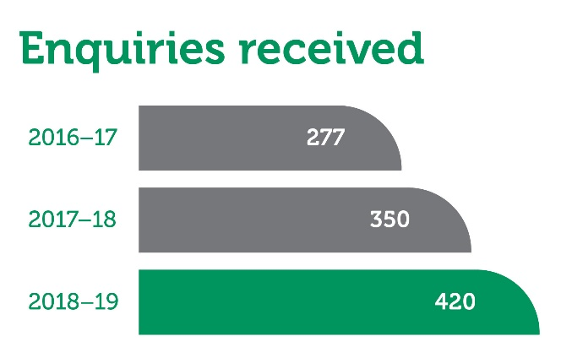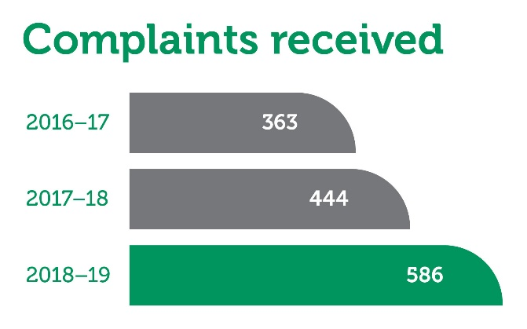

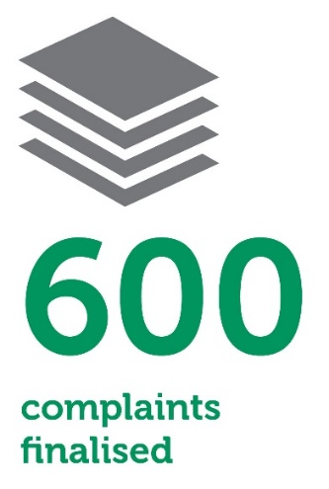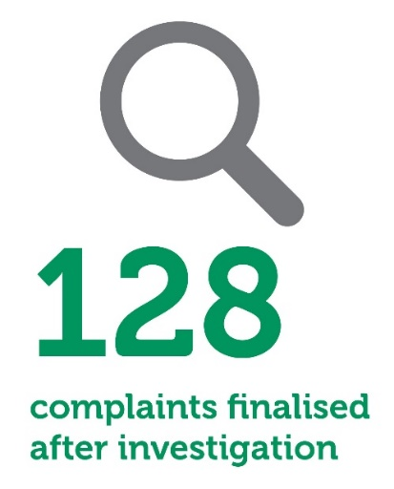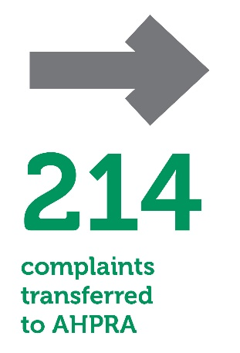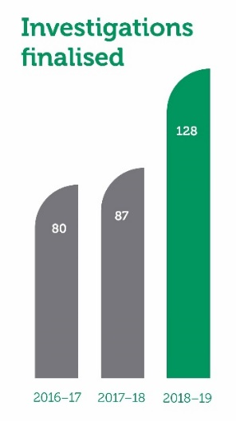

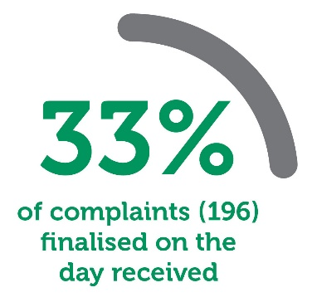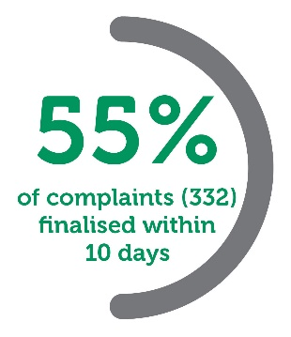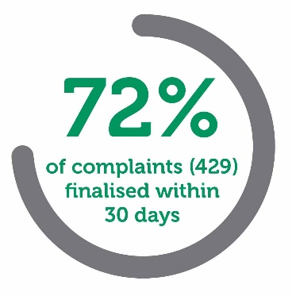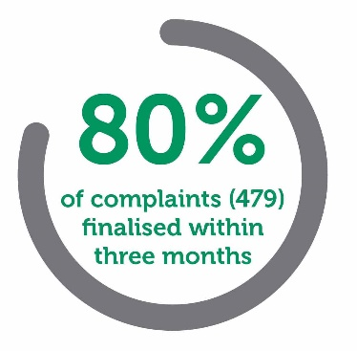

# Who complaints were about

AHPRA and the National Boards regulate 16 professions. The number of complaints we receive about each National Board appears to be linked to the size of the profession the National Board represents, as well as the number of notifications received about practitioners who are registered in each profession (see Table 1).

As in previous years, most complaints to our office relate to the regulation of the medical, nursing and midwifery, and psychology professions.

We also note that all complaints received by our office involve AHPRA in some way. This is because AHPRA is the point of contact for health practitioners, notifiers and other members of the public in relation to the National Scheme.

**Table 1: Registration, notification and complaint numbers in 2018–19 by health profession[3]**

|  |  |  |  |  |  |  |
| --- | --- | --- | --- | --- | --- | --- |
| **Profession** | | **Registered health practitioners** | **Notifications received by AHPRA** | **Applications for registration received by AHPRA** | **Complaints received by AHPRA** | **Complaints received by our office** |
| Medical | 118,996 | | 5,359 | 17,247 | 121 | 246 |
| Nursing and midwifery | 416,943 | | 1,826 | 36,684 | 73 | 145 |
| Psychology | 37,783 | | 535 | 5,445 | 46 | 90 |
| Dental | 23,730 | | 749 | 1,664 | 15 | 28 |
| Physiotherapy | 33,792 | | 106 | 3,667 | 8 | 13 |
| Occupational therapy | 22,412 | | 59 | 2,524 | 9 | 12 |
| Chinese medicine | 4,892 | | 37 | 669 | 3 | 7 |
| Medical radiation  practice | 16,683 | | 31 | 1,587 | 6 | 7 |
| Podiatry | 5,361 | | 53 | 445 | 2 | 7 |
| Pharmacy | 31,955 | | 398 | 3,440 | 5 | 6 |
| Paramedicine | 17,323 | | 31 | 18,457 | 2 | 4 |
| Chiropractic | 5,550 | | 85 | 392 | 3 | 2 |
| Osteopathy | 2,546 | | 19 | 280 | 2 | 2 |
| Optometry | 5,781 | | 41 | 426 | 2 | 1 |
| Aboriginal and Torres Strait Islander health practice | 690 | | 9 | 152 | 0 | 0 |
| Other/unknown | N/A | | N/A | N/A | 0 | 16 |
| **Total** | | **744,437** | **9,338** | **93,079** | **297** | **586** |

# Where complaints came from

We receive complaints from across Australia and also from people located outside Australia who have been in contact with AHPRA or a National Board.

As in previous years, most of the complaints to our office in 2018–19 came from people located in Victoria (see Figure 5). This trend is likely due to the large number of registered health practitioners who are part of the National Scheme in Victoria.

It is also relevant that New South Wales and Queensland have different arrangements in place for making notifications about health practitioners, and these arrangements affect the number of complaints we receive from these locations.

In New South Wales, notifications are handled by the Health Care Complaints Commission and the Health Professional Councils Authority. We do not have power to receive complaints about how a notification has been handled by these entities.

In Queensland, complaints about health practitioners are handled by the Office of the Health Ombudsman. The Office of the Health Ombudsman assesses each complaint it receives to determine if it should be referred to AHPRA or should be managed by the Office of the Health Ombudsman. We only handle complaints about a matter if it has been referred to AHPRA by the Office of the Health Ombudsman.

**Figure 5: Complaints made to our office in 2018–19 by location of the complainant**

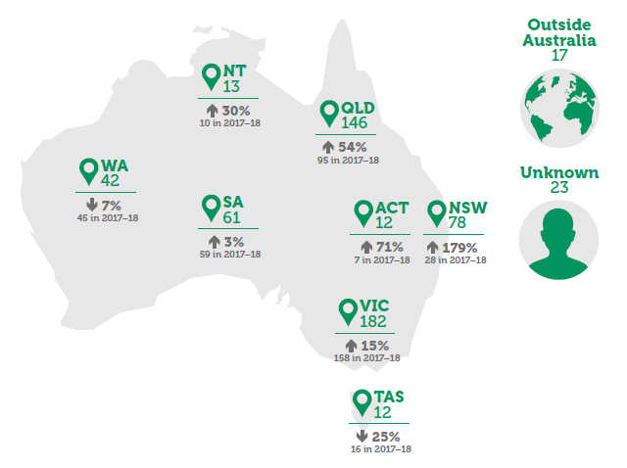

Clara’s story

Clara made a notification about Dr Alexander, who had written an independent expert opinion report about her husband’s medical condition.

She believed there were factual errors in the report because Dr Alexander stated he had examined her husband in person, when he had not.

After assessing the notification, the Medical Board of Australia decided to take no further action in relation to Dr Alexander.

Clara made a complaint to us because she believed the reasons for the Medical Board’s decision were incorrect. She was concerned about the Medical Board’s conclusion that Dr Alexander did not say he examined Clara’s husband in person, when she was able to clearly highlight sections in Dr Alexander’s report where he stated he had done so.

Our assessment of Clara’s complaint led us to agree that the reasons for the Medical Board’s decision were not accurate based on the evidence it had before it.

After we raised these concerns with AHPRA, AHPRA resolved to return Clara’s notification to the Medical Board for further consideration.

Clara was thankful for the assistance provided by our office.

# Common complaint themes

Our office is dedicated to tracking and grouping complaints to identify common trends. This allows us to bring systemic issues to the attention of AHPRA and the National Boards so improvements can be made.

As in previous years, most complaints in 2018–19 related to the handling of a notification about a registered health practitioner (see Table 2).

Concerns were mostly raised by the person who made the notification, rather than the health practitioner who was the subject of the notification.

**Table 2: Complaints by type in 2017–18   
and 2018–19**

|  |  |  |
| --- | --- | --- |
| **Complaints by type** | **2017–18** | **2018–19** |
| Handling of a notification | 288 | 305 |
| Handling of a registration matter | 123 | 233 |
| Breach of privacy | 6 | 17 |
| Handling of an FOI matter | 8 | 17 |
| General health regulation concerns | 0 | 12 |
| Other | 19 | 2 |
| **Total** | **444** | **586** |

Many complaints were also about registration matters, particularly delays in the processing and assessment of applications for registration.

Much smaller numbers of complaints were received about privacy-related matters, the handling of FOI requests[4] and other general concerns about health practitioner regulation.

Our analysis of complaints received in 2018–19 has led us to identify several common complaint themes. These themes generally relate to poor communication with the complainant, delays or concerns about information that was identified and provided to the relevant National Board when it made a decision (see Figure 6).

**Figure 6: Common complaint themes identified in 2018–19**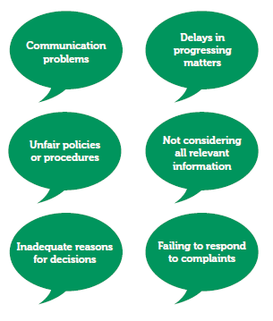

# Freedom of information

## About FOI requests

By law, everyone has the right to request access to information held by AHPRA and the National Boards.

Typically, people make an FOI request if they would like to see what information was considered by AHPRA and the National Boards when making regulatory decisions.

## What we can do

In general, we have two roles in relation to FOI:

* handling complaints about the administrative actions of AHPRA and the National Boards when processing FOI matters (FOI complaints)
* reviewing decisions of AHPRA and the

National Boards in relation to requests for access to documents (FOI review applications).

## FOI complaints

We received 17 complaints about the handling of FOI matters this financial year. This is a 113 per cent increase on 2017–18 (eight).

The most common concern was dissatisfaction with the communication of an FOI decision.

We have found that many people who make complaints about the handling of FOI matters are seeking more information about a regulatory decision that they do not understand or are unhappy with. When we identify this, we talk with the complainant to understand why they are dissatisfied with the decision made by AHPRA or a National Board. This may result in our office suggesting alternative ways for the complainant to get the outcome they are seeking.

## FOI review requests

On 1 February 2019 our office was given the power to review decisions made by AHPRA, its Management Committee and the National Boards in relation to requests for information made under the *Freedom of Information Act 1982* (Cwlth).

This new role means we can:

* affirm the original decision
* vary the original decision

make a fresh decision.

We also consider agreements or applications for extensions of time to process FOI requests and can declare a person to be a vexatious applicant in circumstances where their actions in making an FOI request involve an abuse of process.

Our office received and considered 29 matters relating to FOI requests. Most of these matters were applications by AHPRA for an extension of time to process an FOI request (14). We received eight requests to review an FOI decision made by AHPRA and seven notices of agreed extensions of time for AHPRA to process an FOI request.

## Increasing our capacity

The review of FOI decisions can take a lot of time and resources. This is because many complex documents may need to be carefully reviewed.

Our office is dedicated to continuing to provide a timely and high-quality service. To ensure we can achieve this, our team welcomed a new FOI review officer onto our staff towards the end of the financial year.

Our professional team   
provides empathetic,   
timely and high-quality   
services

# Understanding how the complaints process works

We encourage all health practitioners and community members to share their concerns with us.

## Step 1: hearing the complaint

The first step in the complaints process is registering a concern with us. This can be done by email, sending us a completed complaint form or other information about the concern, or by calling our office to discuss the matter.

We initially clarify the information provided to ensure we are the organisation best placed to help with the concern. If we cannot consider the complaint, we will discuss this with the complainant and recommend another organisation to contact.

We also provide all complainants with general advice about what our office can and cannot do, depending on the concerns raised in the complaint. We cannot, for example, provide legal advice or advocate for any individual because our office is independent and impartial.

**We acknowledge receipt of complaints within three working days.**

## Step 2: assessing the complaint

Once we are satisfied we have the power to consider the issues raised in the complaint, we conduct an assessment of the available information to determine the next steps.

We sometimes ask for additional information from either the complainant or AHPRA to enhance our understanding of the complaint issues.

Usually, we then decide to:

* investigate the complaint
* not investigate the complaint, or

seek the complainant’s consent to transfer the complaint directly to AHPRA for a response.

We inform complainants about our assessment and are transparent about the reasons for our decisions.

**We decide and let complainants know whether we can investigate complaints within 14 working days.**

### Transfer to AHPRA

We have the ability to transfer complaints directly to AHPRA’s National Complaints Team. In our experience, this process has been a successful way to quickly resolve concerns that have not yet been addressed by AHPRA’s internal complaints process.

Importantly, we ask for the complainant’s consent before transferring their complaint to AHPRA.

AHPRA has provided our office with an assurance that it will contact the complainant to acknowledge receipt of the transferred complaint within two business days. Further, AHPRA will fully respond to the complaint within 20 business days.

We advise complainants that they can return to our office to discuss their complaint further if:

* AHPRA does not acknowledge receipt of the complaint within two business days
* AHPRA does not fully respond to the complaint within 20 business days

the complainant remains dissatisfied after AHPRA has responded to the complaint.

## Step 3: investigating the complaint

When we decide to investigate a complaint, we begin by requesting that AHPRA provides us with all relevant information about the concern raised. This can include reports and correspondence, internal working documents, records of telephone conversations and meetings, and copies of any relevant policies or procedures.

We carefully assess all information provided to us. Our analysis may lead us to request additional information or ask the complainant or AHPRA to answer specific questions.

**We provide complainants with a progress update every six weeks.**

**We aim to return telephone calls within three working days and respond to written communication within 14 working days,**

## Step 4: finalising the complaint

In the final stages of our investigation, we provide complainants with our proposed findings. This step is an opportunity for complainants to make any final comments before we conclude the investigation.

After taking all points of view and evidence into consideration, we make a final decision regarding the complaint. Possible outcomes include:

* providing the complainant with further information about the action or decision that led to the complaint
* assisting AHPRA to resolve the complaint (for example, by agreeing to return the matter to the relevant National Board for reconsideration)

providing AHPRA with formal comments and/or suggestions for improvement (for example, suggesting an amendment to a process or policy).

**We aim to finalise complaints within three months and deal with more complex cases within nine months.**

### Internal review

We encourage feedback so we can continue to improve our processes.

People who are not happy with how their complaint was managed can request an internal review of the outcome by another team member.

There appears to be a high level of satisfaction with our complaints service given we received only eight requests for internal review in 2018–19. Only one of these requests was deemed to have grounds for review based on our criteria for assessing internal review requests.

# Our service charter

Our service charter provides the public with a clear understanding of what to expect when making a complaint. It is published on our website to ensure we are open about our processes and procedures.

This year our office successfully finalised 72 percent of complaints within 30 days, and 95 per cent of complaints within nine months (see Figure 7).

**Figure 7: Complaints finalised in 2018–19 in 30 days and in nine months**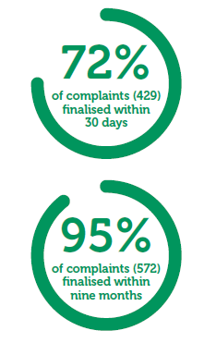

# Resolving a complaint through investigation: Haruto’s story

Haruto made notifications about medical practitioners who were involved in his care when he was admitted to hospital. Haruto believed he was inappropriately prescribed medications, which led to a severe reaction and caused significant discomfort and distress. He also raised concerns about the follow-up care he received. The Medical Board of Australia assessed Haruto’s notifications and decided to take no further action.

## Hearing Haruto’s complaint

Haruto complained to our office about the way his notifications were handled. Our staff heard his concerns that:

* AHPRA did not   
  present the Medical Board with all of the supporting information he provided.
* The Medical Board’s decision was based on inaccurate information provided by the medical practitioners who were involved.
* AHPRA failed to provide him with adequate reasons for the Medical Board’s decisions to take no further action.
* AHPRA did not respond to his requests for further information about the Medical Board’s decisions and failed to explain the process for making a complaint with AHPRA.

## Assessing Haruto’s complaint

After hearing Haruto’s complaint, we decided to investigate. Our decision was influenced by the following factors:

* Haruto raised concerns about the administrative actions of AHPRA and the Medical Board, particularly the failure to consider all relevant information and the failure to provide adequate reasons for decisions.
* Haruto had already attempted to complain directly to AHPRA, but he was not satisfied with the response.

## Investigating Haruto’s complaint

We investigated Haruto’s complaint and identified that:

* AHPRA’s letter to Haruto about the Medical Board’s decision could have contained a more detailed explanation about the reasons the Medical Board decided to take no further action.
* The Medical Board did not specifically consider the issue of follow-up care, which Haruto raised in his notifications.
* AHPRA did not comply with its obligations in its Service charter and Complaint handling policy when managing Haruto’s complaints about the outcome of the notifications.

## Finalising Haruto’s complaint

Based on our investigation, AHPRA agreed to provide Haruto with more detailed reasons about the Medical Board’s decisions.

Further, the issue relating to follow-up care was returned to the Medical Board for consideration.

The Ombudsman and Commissioner also made formal comments to AHPRA about the issues we identified, with a view to improving the experience of notifiers in the future.

Our staff communicated this outcome to Haruto, who was satisfied that his complaint had been heard and action taken to address it.

# Transferring a complaint to AHPRA: Gabriel’s story

Gabriel contacted us because he had concerns with AHPRA’s communication after he made a notification about a medical practitioner. He explained that he felt frustrated by the difficulties he had encountered, and this undermined his confidence that the notification was being handled fairly.

## Hearing Gabriel’s complaint

Gabriel explained that he had sent an email to AHPRA outlining his concerns about communication but did not receive a response. He attempted to contact his case officer over three consecutive days but was not able to speak with her.

During Gabriel’s most recent phone conversation with AHPRA, there was a problem with the phone connection and he had to keep repeating himself and was eventually hung up on.

## Assessing Gabriel’s complaint

We assessed Gabriel’s complaint and determined that it would be appropriate to transfer the matter to AHPRA’s National Complaints Team. This was because:

* We generally require complainants to exhaust AHPRA’s internal complaint process before taking any further action, and Gabriel had not yet made a formal complaint directly to AHPRA.

We considered that AHPRA should be able to quickly and effectively resolve the communication issues experienced by Gabriel without further involvement from our office.

## Transferring Gabriel’s complaint

Our office sought Gabriel’s consent before reaching out to AHPRA’s national complaints manager to explain the details of his concerns.

## Finalising Gabriel’s complaint

AHPRA wrote to Gabriel to acknowledge his concerns and provide him with information about what to expect next from its complaint process.

AHPRA also explained that the reason Gabriel was unable to contact his case officer was because she was unexpectedly out of the office due to illness.

Gabriel expressed his thanks for the prompt and courteous assistance provided by our office.

Our investigations   
ensure the   
National Scheme   
is accountable and   
responsive

# Outcomes: complaints about the handling of notifications

This year, most of the complaints received by our office were about the handling of a notification by AHPRA and a National Board.

Over half of all complaints to our office (52 per cent) related to the handling of a notification.

The number of complaints of this type increased by 6 per cent compared with 2017–18 (see Figure 8).

**Figure 8: Notification-related complaints received from 2016–17 to 2018–19**

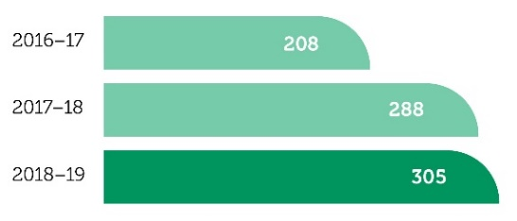

## About the notification process

Anyone can make a notification to AHPRA about a registered health practitioner if they have a concern about the health, conduct or performance of the practitioner.[5]

AHPRA gathers information about the notification and presents it to the relevant National Board. The National Board then decides whether it needs to take regulatory action to protect the public.

## Concerns raised about the handling of a notification

This financial year, complainants typically raised concerns that:

* AHPRA and/or the National Board misunderstood the notification or did not address all issues raised in the notification
* the National Board did not consider all relevant information when making decisions about the notification
* AHPRA did not adequately explain the reasons for the National Board’s decisions
* AHPRA’s communication was inadequate, particularly in relation to updates about the progress of the notification
* AHPRA did not progress the notification in a timely manner
* AHPRA did not provide information about its internal complaint-handling process to a person who expressed dissatisfaction

AHPRA did not respond to a complaint about the handling of a notification in accordance with its policy.

In 2018–19 most complaints about the handling of notifications were made by notifiers (80 per cent). A significantly smaller number of complaints were made by health practitioners who were the subject of notifications (17 per cent) and members of the public who are not a party to notifications (3 per cent) (see Figure 9).

This trend is consistent with previous years.

**Figure 9: Types of notification-related complaints in 2018–19**

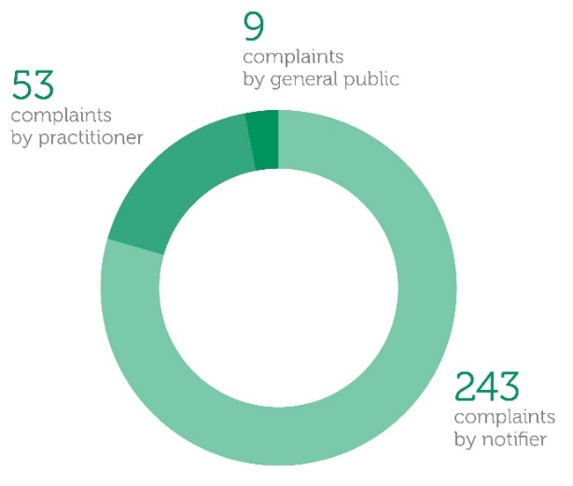

Spotlight

Concerns about a lack of updates from AHPRA about the progress of an investigation

When a notification proceeds to an investigation, AHPRA and the National Boards are required by law to provide the notifier, and the registered health practitioner who is the subject of the notification, with written updates about the progress of the investigation at least every three months.

Our office frequently hears concerns from complainants about long delays in receiving updates from AHPRA. Complainants regularly report that this issue has a negative impact on their confidence that the matter is being appropriately dealt with and they express frustration, and sometimes distress, at the lack of information provided.

The Ombudsman and Commissioner has provided comments to AHPRA about its failure to consistently comply with its legislative obligation to provide regular updates to notifiers and practitioners.

In response, AHPRA advised that it will be conducting a quality assurance exercise in 2019–20, and compliance with the obligation to provide regular investigation updates will be one of the focuses of this exercise.

AHPRA advised that it will amend its processes to allow notifications officers and investigators to sign correspondence updating notifiers and practitioners about the progress of their notification. As this correspondence has traditionally been signed by more senior staff, this step should facilitate a more efficient process for investigation updates.

Concerns about the handling of new information after a National Board has made a decision about a notification

AHPRA regularly advises individuals that a National Board’s decision in relation to a notification is final, except if new information about the matter comes to light that leads the National Board to reconsider its decision.

A common complaint theme is that AHPRA has not properly considered new information provided to it after a notification has been finalised.

Investigations conducted by our office uncovered that AHPRA did not have documented policies or procedures about the assessment of new information.

The Ombudsman and Commissioner suggested that AHPRA develop guidance for its staff about this important issue, including how the assessment of new information should be recorded and communicated to those involved in the notification.

In response, AHPRA agreed to develop this guidance and it is expected to be released to staff in early 2019–20.

Monica’s story

Monica made a notification about Dr Louise, a medical practitioner who was involved in the care of her husband, Fred, before he passed away. Monica believed Dr Louise prematurely discharged Fred from hospital, which contributed to Fred’s deterioration and subsequent death.

The Medical Board of Australia decided to investigate the matter but ultimately came to the decision to take no further action in relation to Dr Louise. The Medical Board was satisfied that Dr Louise undertook an appropriate assessment of Fred and that she did not discharge Fred from hospital prematurely.

Monica complained to us because she believed AHPRA should have conducted a more comprehensive investigation. One of Monica’s key concerns was that AHPRA and the Medical Board did not adequately deal with her allegation that Dr Louise should have consulted with a more senior practitioner about the decision to discharge Fred from hospital.

Our investigation did not identify any administrative errors in AHPRA’s investigation of Monica’s notification, or in the decision-making process adopted by the Medical Board. However, we identified several concerns relating to AHPRA’s communication with Monica. In particular, AHPRA did not send Monica key correspondence about the notification process and also did not communicate the Medical Board’s decision regarding the notification in a timely manner (it took AHPRA more than three and a half months after the Medical Board’s decision to advise Monica of the outcome).

After carefully explaining our decision to Monica, we provided formal comments to AHPRA highlighting our concerns about its communication with Monica.

AHPRA acknowledged that its communication was not to its expected standards in this instance and apologised to Monica.

# Outcomes: complaints about the handling of registration matters

Forty per cent of all complaints to our office this year were about the health practitioner registration process.

## About the registration process

Practitioners must be registered by the National Board that represents their profession.

Registered practitioners are required to renew their registration every 12 months.

## Concerns raised about the registration process

Complaints about the registration process generally related to three key areas:

* delays in the processing and assessment of applications for registration and renewals of registration (149 complaints)
* unfair processes or policies related to assessing applications for registration (75 complaints)

registration fees (nine complaints) (see Figure 10).

**Figure 10: Types of registration-related complaints received in 2018–19**

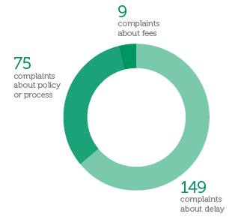

## Increase in registration-related complaints

The number of registration-related complaints we received increased by 89 per cent from 2017–18 to 2018–19 (see Figure 11).

**Figure 11: Registration-related complaints received between 2018-19**

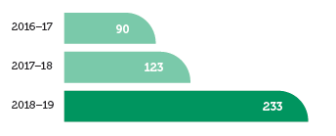

Most of these complaints related to delays in the processing and assessment of registration applications. In 2017–18 we received only 56 complaints of this type, which increased to 149 complaints in 2018–19.

The most significant peak in complaints was in early 2019, largely due to nurses seeking registration and psychologists transitioning from provisional to general registration during the first few months of the year. This is typically a busy time for AHPRA due to the number of graduates seeking registration. AHPRA acknowledged the backlog of registration matters and advised that it had allocated more resources to address the issue.

We have been working closely with AHPRA to understand the cause of the delays and to identify steps that can be taken to improve the experience of applicants. In particular, our office has been encouraging AHPRA to update its communications to applicants to better manage their expectations about the length of time it may take to process and assess registration applications.

We will continue to closely monitor this issue in 2019–20

Doctor Bradley’s story

Dr Bradley made an application to AHPRA and the Medical Board for limited registration

to undertake a period of supervised practice as a junior medical officer.

Dr Bradley contacted us to raise concerns that his application was not being handled in a timely manner. He believed the delay had resulted in the withdrawal of an offer of employment, which exacerbated the financial hardship he was suffering because he was unable to work as a medical practitioner while unregistered.

Our investigation found that AHPRA had not acknowledged Dr Bradley’s request to speed up the assessment of his application for registration due to severe financial hardship. We also noted that while AHPRA was not satisfied that Dr Bradley had provided enough evidence to satisfy the registration requirements, it did not request additional supporting information from him early in the registration process. Dr Bradley had proactively sought to ensure the Medical Board had all the information it needed, and it would have been better if AHPRA had asked Dr Bradley to provide evidence to resolve its concerns before his application was assessed by the Board. This could have saved time and also reduced stress for Dr Bradley, who was later asked to provide this information in a short timeframe.

We provided formal comments to AHPRA about the issues we identified in this complaint.

In response to our comments, AHPRA advised that it is undertaking a review of its policy regarding financial hardship. It intends to broaden the scope of the policy to allow for more timely assessment of an application for registration where the applicant is experiencing severe financial hardship while recognising the importance of ensuring an applicant meets all of the necessary requirements to practise safely. AHPRA aims for the policy to be finalised in late 2019.

Spotlight

Concerns about AHPRA’s approach to refunding registration fees

During 2018–19 we received complaints about AHPRA’s approach to refunding registration fees.

AHPRA’s Refunds policy states that it will not refund fees where registration is voluntarily surrendered, suspended or cancelled. Its ‘Requesting a refund’ procedure also clarifies that there are no pro rata refunds of fees (unused portions of registration fees are not refunded).

Complainants raised concern with our office that this approach is unfair because it is unreasonable to expect practitioners to pay the full annual registration fee when they are only registered for part of the year.

In response to our enquiries, AHPRA explained that registration fees are received upfront for the National Scheme and the National Boards to undertake their regulatory functions.

After taking all information into consideration, we observed that there is a lack of clarity regarding the purpose of registration fees. We therefore suggested that AHPRA better articulate the principles underpinning why practitioners are required to pay registration fees and make these principles publicly available.

AHPRA agreed to implement our suggestions. It is expected that a new Refunds policy will be published in mid-2019–20.

Seo-yun’s story

Seo-yun applied to AHPRA for general registration as an occupational therapist. In total, it took six months for Seo-yun’s registration application to be finalised. This delay was largely because four months passed before Seo-yun’s application was allocated to a case manager for assessment.

Seo-yun let AHPRA know on multiple occasions that she was experiencing financial hardship because she was unable to work as an occupational therapist while waiting for her registration to be approved. Despite these concerns, AHPRA advised Seo-yun that she was not eligible for a partial refund of her registration fee.

Seo-yun complained to our office that the six-month period to assess and finalise her application for registration was not reasonable. She felt that AHPRA ought to provide her with a partial refund of her registration fee because she was unable to practise for six months and therefore experienced financial hardship.

We made preliminary enquiries with AHPRA and it agreed to refund Seo-yun’s registration application fee as a one-off gesture of good will.

AHPRA also acknowledged the suggestion (as previously made by our office) that AHPRA review its policies in relation to financial hardship. AHPRA confirmed that work had begun on drafting a new financial hardship policy and that relevant stakeholders would be consulted as part of this process.

# Outcomes: complaints about privacy matters

## Privacy-related complaints

Our office accepts complaints from individuals who have a concern about how AHPRA and the National Boards have handled their personal information.

The *Privacy Act 1988* (Cwlth) promotes and protects the privacy of individuals by regulating the way personal information is handled.

AHPRA and the National Boards keep several files that may contain personal information, including:

* registration files
* notification files
* investigation files
* public register information, including previous registration and disciplinary information
* legal files
* employment files

general administration files and documents.

## Our role in relation to complaints about privacy

Our office can address privacy-related complaints by:

* making a determination about what action should be taken to resolve a complaint about a breach of privacy
* making a declaration that the complainant is entitled to compensation for any loss or damage they suffered because their privacy has been interfered with.

## Types of privacy-related complaints

To date, we have received very few complaints about privacy matters. In 2018–19 we received only one complaint that was specifically considered by the Ombudsman and Commissioner in her capacity as Privacy Commissioner.

From time to time, however, our office receives complaints about an administrative action of AHPRA that also raises privacy concerns. Depending on the nature of the matter, these complaints can be dealt with by the Ombudsman and Commissioner in her capacity as Ombudsman.

In 2018–19 we received 16 complaints that fell into this category. This represents a significant increase in privacy-related complaints compared with 2017–18, when we received only six complaints of this type.

## Notifiable Data Breaches Scheme

AHPRA and the National Boards are required by law to notify our office about data breaches involving personal information that are likely to result in serious harm to any individual. A data breach of this nature is called a ‘notifiable data breach’.

Since the scheme came into effect on 22 February 2019, we have not received any formal notifications from AHPRA or the National Boards about eligible data breaches.

## Concerns about publishing information regarding practitioners on the public register

Since early 2018 AHPRA and the National Boards have published links to public decisions of courts and tribunals on the public register of health practitioners.

The public register is a database of all registered health practitioners in Australia. It was created with a view to making information more accessible to the public about the registration status of individual health practitioners.

During 2018–19 we received complaints from practitioners about the publication of links to court and tribunal decisions on their individual record, with many arguing that this action was a breach of their privacy. Practitioners were also uncertain about the criteria for determining whether a link to a decision should be published, as well as if they could request that AHPRA remove links to certain decisions.

Following consultation, AHPRA agreed to clarify its principles for assessing whether a link to a court or tribunal decision will be published.

AHPRA also agreed to make information publicly available about this issue to ensure practitioners are able to find answers to frequently asked questions about publishing links to court and tribunal decisions.

# Creating systemic change

Our office influences improvements in the National Scheme for the benefit of all Australians.

We influence change in formal and informal ways by viewing each complaint as a valuable insight into the health of the National Scheme.

## Providing comments, suggestions for improvement and positive feedback

This financial year 34 per cent (44) of all investigations (128) concluded with the Ombudsman and Commissioner providing to AHPRA and the relevant National Board:

* suggestions for improvement
* formal comments, or

positive feedback (see Figure 12).

These comments and suggestions are intended to influence continuous improvement in the administrative actions of AHPRA and the National Boards.

We are proud to have continued our focus on creating systemic improvements in 2018–19. The Ombudsman and Commissioner provided 19 per cent more formal comments and suggestions in 2018–19 compared with the previous financial year.

**Figure 12: Investigations that resulted in suggestions for improvement, formal comments and positive feedback in 2018–19**

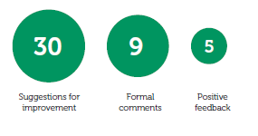

### Suggestions for improvement

Many of the suggestions for improvement have resulted in important outcomes for the National Scheme. Examples include AHPRA:

* reviewing or creating a policy or procedure in response to a matter raised (for example, a conflict of interest policy and contact management policy)
* updating its publicly available information to better inform health practitioners, notifiers and other individuals about particular issues
* making its services more accessible to people who do not have access to a telephone or computer

improving its recordkeeping.

### Formal comments

In some matters, the Ombudsman and Commissioner decided to make formal comments rather than specific suggestions for improvement.

The purpose of these comments is to draw AHPRA’s attention to an issue that may be an isolated incident or relates to a problem that AHPRA is already addressing.

### Positive feedback

While our suggestions for improvement and formal comments generally highlight aspects of a matter that could have been handled better, the Ombudsman and Commissioner also provides positive feedback where warranted.

On five occasions this year the Ombudsman and Commissioner wrote to AHPRA to highlight where a matter was handled well.

The positive feedback related to:

* communicating clearly and in a timely way with health practitioners and notifiers
* proactively apologising for errors
* good recordkeeping

collaborating effectively with our office.

Spotlight

English Language Skills Registration Standard

Our office received several complaints about the procedures for assessing whether practitioners meet the required English language skills to be registered to practise in Australia.

People who are required to demonstrate they meet the English Language Skills Registration (ELSR) Standard have expressed concern with:

* how the ELSR Standard requirements are articulated

the application of current policy and procedures by AHPRA.

Our office has suggested to AHPRA that, in response to these concerns, it would be ideal if AHPRA could:

* review and update public information about the ELSR Standard

update its policy to ensure it is clear and supported by detailed procedures, staff training and an appropriate quality assurance mechanism.

AHPRA has taken steps to address these suggestions. We will continue to monitor AHPRA’s response to ensure a fair process for practitioners applying for registration.

Aisha’s story

Aisha completed her nursing qualification as a mature-age student and applied for registration via the extended education pathway of the Nursing and Midwifery Board’s ELSR Standard. AHPRA advised Aisha that she was required to complete an English language test to satisfy the ELSR Standard.

Aisha believed AHPRA’s request that she complete an English language test was not fair because it did not recognise her particular circumstances. Aisha explained to us that she was 12 years old when she moved to Australia. After completing one year of language school within an Australian primary school, Aisha completed secondary, vocational and tertiary education in Australia. Aisha emphasised that she had lived in Australia for more than 30 years and, though she is multilingual, the primary language she speaks at home is English.

After hearing Aisha’s concerns, we made enquiries with AHPRA about Aisha’s application. AHPRA advised that it had agreed to present Aisha’s application to the Nursing and Midwifery Board for consideration. After taking into consideration Aisha’s application, the original assessment and the enquiries from our office, AHPRA decided to seek legal advice in preparation for the Nursing and Midwifery Board meeting.

The Nursing and Midwifery Board considered the matter soon after and decided to grant Aisha registration without requiring her to sit an English language test.

Aisha was pleased with the quick and professional assistance provided by this office.

# Own motion investigation

## Safeguarding the confidentiality of notifiers

In late 2018 AHPRA asked the Ombudsman and Commissioner to conduct an independent review of the confidentiality safeguards for people making notifications about registered health practitioners.

This announcement came after the conviction of Dr Brian Holder, a South Australian general practitioner, for the attempted murder of Ms Kelly Akehurst, a pharmacist who made a notification about Dr Holder’s prescribing practices.

Importantly, Dr Holder and Ms Akehurst did not know each other before Ms Akehurst raised her concerns with AHPRA and the Medical Board of Australia about prescriptions written by Dr Holder.

## Background to the review

AHPRA’s current practice is generally to provide practitioners with notice that a notification has been made about them, including information that identifies the notifier.

There are existing ways in which people can make notifications without having their identity disclosed to the practitioner. In the case of confidential notifications, the identity of the notifier is known to AHPRA but is withheld from the practitioner (to the greatest extent possible). Alternatively, an anonymous notifier does not identify themselves to AHPRA, which means AHPRA cannot advise the practitioner of the notifier’s identity.

The key issue considered by this review was whether these current practices adequately safeguard the confidentiality of notifiers.

## The review process

The Ombudsman and Commissioner began the confidentiality review in January 2019.

The first stage of the review involved gathering and reviewing information from AHPRA. This included:

* conducting interviews with staff
* evaluating relevant policies and process documents
* analysing a sample of files involving anonymous or confidential notifications

assessing data regarding complaints about the handling of anonymous and confidential notifications.

The second stage of the review involved the Ombudsman and Commissioner meeting with relevant stakeholders to conduct interviews, including:

* practitioners who had been the subject of a notification
* professional indemnity insurance providers
* AHPRA’s Community Reference Group

Ms Akehurst.

The third stage of the review involved looking at the policies and processes of other similar organisations regarding the confidentiality of complainants. This included organisations both within and outside Australia.

Last, the Ombudsman and Commissioner gathered more detailed information from AHPRA regarding issues or concerns that became apparent during the review process. This included reviewing more data on confidential and anonymous notifications and clarifying specific steps in the notification process.

The report is currently being finalised.



We work collaboratively   
to ensure the health   
practitioner regulation   
system is accessible and   
transparent

# Working with AHPRA

Our office values working collaboratively with AHPRA to provide meaningful outcomes for complainants and to make systemic improvements.

We regularly communicate with AHPRA, particularly to discuss emerging complaint themes.

This financial year we were pleased to see AHPRA increase its communication about what notifiers and health practitioners can expect from the notification process. In particular, we found AHPRA’s new video series featuring health practitioners speaking about their lived experience and sharing their advice for others to be a valuable resource.

## Improvements to AHPRA’s handling of complaints

Following an internal audit of its administrative complaint-handling process, AHPRA took steps to develop and implement a new complaint policy and procedure in 2018–19.

The Ombudsman and Commissioner was invited to participate in this process by forming part of the steering committee tasked with managing this project.

We were pleased to see AHPRA has successfully implemented the new policy and procedure. Further to this, AHPRA has created a new National Complaints Team to effectively and consistently deal with complaints.

Following implementation, we have observed significant improvements in AHPRA’s management of complaints, particularly in relation to timeliness and the quality of communications with complainants.

We look forward to continuing to work with AHPRA’s National Complaints Team in 2019–20.

## Transfers to AHPRA

Since its introduction in January 2018, the number of complaints referred to AHPRA via our warm transfer process has continued to grow.

This process enables us to, with the complainant’s consent, transfer the complaint directly to AHPRA’s National Complaints Team for management.

The transfer process aims to reconnect AHPRA and the complainant so it has an opportunity to address the complainant’s concerns before our office becomes involved.

The results of this process have been positive. This financial year 214 people consented to transferring their complaint to AHPRA, which is a 240 per cent increase compared with the previous financial year (63).

Most transfers related to complaints about delays in the registration process (51 per cent), the handling of a notification from the point of view of a notifier (27 per cent) and registration processes and policies (12 per cent) (see Table 3).

**Table 3: Types of complaints transferred to AHPRA in 2017–18 and 2018–19**

|  |  |  |  |
| --- | --- | --- | --- |
| **Type of complaints** | **2017–18** | | **2018–19** |
| Registration delay | 21 | | 110 |
| Handling of a notification – complaint by a notifier | 19 | | 57 |
| Registration process  or policy | 10 | | 26 |
| Handling of a notification  – complaint by practitioner | 12 | | 10 |
| Breach of privacy/  Handling of personal  information | 0 | | 5 |
| Registration fees | 0 | | 4 |
| Handling of an FOI matter | 0 | | 2 |
| Other | 1 | | 0 |
| **Total** | | **63** | **214** |

Of the people who initially agreed to transfer their complaint to AHPRA, 19 per cent returned to our office after the transfer. The reasons for returning to our office were to:

* express dissatisfaction with AHPRA’s response to the complaint (28)
* advise that AHPRA did not acknowledge receipt of their transferred complaint within the agreed timeframe (11)
* advise that AHPRA had not responded in full

to their transferred complaint within the agreed timeframe (two).

## Assisting AHPRA to resolve complaints

When assessing and investigating complaints, we look for opportunities to work with AHPRA to quickly and effectively resolve complaints.

This could involve asking AHPRA to reconsider a decision, issue an apology or refund a fee. If AHPRA agrees to take the suggested action to resolve the complaint, we call this an ‘assisted resolution’.

In 2018–19 we recorded 44 assisted resolutions, including:

* 33 during the complaint assessment stage

11 during the investigation stage.

This was an increase in assisted resolutions compared with the previous financial year (31).

## Review of the interface between AHPRA and our office

In February 2019 our office and AHPRA jointly commissioned an independent review of the interface between our agencies.

Due to a significant increase in the number of complaints made to our office in recent years, it is more important than ever to evaluate and consider ways that our office and AHPRA can improve our joint ability to efficiently and effectively respond to complaints.

The reviewer, Ms Rae Lamb (former Australian Aged Care Complaints Commissioner), was asked to consider ways to streamline the interface to facilitate earlier resolution of complaints wherever possible.

### Recommendations

Ms Lamb recommended that our office and AHPRA:

* review and update the current *Memorandum of understanding* and *Administrative arrangements agreement* between our offices, giving particular attention to:
* beginning complaint assessments by considering whether early resolution can be achieved
* our office contacting AHPRA at the assessment stage to discuss its willingness and capacity to try to resolve the matter itself
* introducing a process where AHPRA is given an opportunity to resolve the complaint, but the file remains open with us and AHPRA must report back about the steps it has taken to resolve the matter
* develop written guidelines setting out the criteria for deciding which complaints are suitable for early resolution or transfer to AHPRA, or investigation by us
* review and agree on realistic timeframes for AHPRA to respond to our requests for information and arrangements for sharing information

increase communication and education about how our agencies work together and the role of our office.

### Next steps

Both our office and AHPRA are committed to implementing these recommendations.

Following a workshop in May 2019 our office and AHPRA agreed to form a working group focused on implementing a new early resolution complaint resolution mechanism.

Our office and AHPRA have begun implementing several recommendations, including:

* trialling bi-weekly teleconferences between our offices to facilitate early resolution

working with AHPRA to review our *Memorandum of understanding* and associated administrative arrangements by the end of 2019.

Xenia’s story

Xenia made a notification about Dr George, a medical practitioner who was involved in the care of her son, Adrian, before he passed away. Adrian attended an appointment with Dr George three days before his death. Xenia believed Dr George failed to identify the seriousness of Adrian’s condition at that appointment.

The Medical Board of Australia decided to investigate the matter. After considering all available information, the Medical Board decided to take no further action in relation to Dr George.

Xenia contacted us to raise concerns that, although she contacted AHPRA on more than one occasion to ask for a more detailed explanation regarding the Medical Board’s decision, she had not been provided with adequate reasons for the Medical Board’s decision.

After hearing Xenia’s concerns, our office began an investigation into her complaint. The investigation found that all relevant processes and policies were followed when handling Xenia’s notification. We therefore concluded it was open to the Medical Board to decide to take no further action in relation to Dr George.

However, we agreed with Xenia that the reasons for the Medical Board’s decision had not been adequately communicated to her. Xenia had been provided with three short sentences explaining the Medical Board’s decision, which was particularly upsetting for Xenia given the notification involved the death of her son.

We asked AHPRA to review its correspondence to Xenia and it agreed to draft a new letter with a more detailed explanation of the Medical Board’s decision. AHPRA also apologised to Xenia for the way it initially communicated with her and acknowledged that, although it is likely that she would always have been disappointed with the Medical Board’s decision, better communication may have gone some way to alleviate Xenia’s concerns about Dr George.

Xenia was grateful for the further explanation of the Medical Board’s decision, and she thanked us for the time put in to responding to her concerns.

# Working with the National Boards

Our office works closely with the 15 National Boards to identify and address complaint trends.

## Presentations

Our office has welcomed the opportunity to engage with National Boards throughout the year to discuss common complaint themes and to improve board members’ understanding of the role of our office and how our complaints data can inform the work of the National Boards.

This year, the Ombudsman and Commissioner was invited to present to the Physiotherapy Board of Australia in December 2018 and to the Tasmanian Board of the Medical Board of Australia in June 2019.

The Ombudsman and Commissioner also presented at the Medical Board of Australia’s National Conference in May 2019.

We look forward to continuing to increase our engagement with the National Boards in the new financial year.

## Submissions

Our office has provided submissions in response to several consultations by National Boards.

Our submissions are based on our complaints data and our expertise in identifying and addressing systemic issues. Our ability to provide evidence-based responses to proposed changes in guidelines or policies has been beneficial in identifying and addressing potential problem areas.

Our office has been part of four confidential preliminary consultations.

We have also provided a response or submission to several public consultations including the:

* Medical Radiation Practice Board of Australia’s public consultation on the draft revised professional capabilities for medical radiation practice
* Medical Board of Australia’s public consultation paper on the draft revised code of conduct, *Good medical practice: a code of conduct for doctors in Australia*
* Aboriginal and Torres Strait Islander Health Practice, Chinese Medicine Accreditation Committee and Medical Radiation Practice Accreditation Committees’ public consultation on the joint review of current accreditation standards

Medical Board of Australia’s public consultation paper on clearer regulation of medical practitioners who provide complementary and unconventional medicine and emerging treatments.

# Community engagement

We are dedicated to improving our communications and engagement with all who use our services, as well as those who may contact us in the future.

## Engaging with communities

This financial year we continued our efforts to raise our public profile and increase the accessibility of our services.

This included focusing on:

* updating our website
* providing relevant information to health practitioners and relevant organisations about the role of our office

updating our policies and procedures to improve how we engage with people who contact our office.

## Contact with our office

Our staff have provided excellent customer service to an increasing number of people making complaints or enquiries to our office.

People generally contact our office via:

* telephone
* email

post.

This year, we saw a:

* 37 per cent increase (1,940) in the number of telephone calls to our central enquiry line from 2017–18 (1,417)

40 per cent increase (14,908) in the number of visits to our website from 2017–18 (10,637).

* 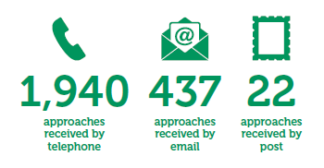

## Our website

Our website is a user-friendly way for people to get information about our office and the services we provide.

This year our website was visited by 11,323 people. Of these people, about 99 per cent (11,229) were new visitors to the website. There were 14,908 website visits.

Our homepage received the most views (6,960), followed by our ‘Make a Complaint’ page (5,975) and ‘About Us’ page (2,682).

Most users accessed our site via desktop computers.

As part of our commitment to being transparent about our work, our website also hosts our key strategic documents and policies.

We also published all monthly and bi-annual complaint reports on our website.

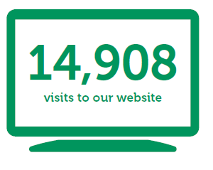

## 

## Engaging with other organisations

We sought to provide more information and increase our engagement with all bodies involved in the National Scheme, including the:

* COAG Health Council
* Australian Health Ministers’ Advisory Council
* Australian Health Practitioner Regulation Agency
* Australian Health Practitioner Regulation Agency Management Committee
* National Boards

Victorian Department of Health   
and Human Services.

## Increasing our capacity

In support of our commitment to improving our stakeholder engagement, our office has welcomed a new communications officer role.

The communications officer is responsible for:

* developing and implementing a stakeholder and media engagement strategy

updating and implementing our media policy.

# Submissions

## Australia’s health workforce: strengthening the education foundation (March 2019)

Our office provided a detailed submission to the consultation paper to inform the health ministers’ response to the final report of the Independent Review of Accreditation Systems within the National Scheme for health practitioners.

This consultation was an important opportunity to highlight that it would be appropriate for our office to handle complaints about the administrative actions of accreditation entities for reasons including:

* It is a more efficient use of resources to extend our remit, rather than establish a new external complaint-handling mechanism.
* People are already approaching us with concerns about accreditation-related matters, which suggests there is some feeling that our office is the appropriate entity to handle these complaints.

Accreditation is closely connected with practitioner registration and it therefore seems natural that the body that handles complaints about administrative actions associated with practitioner registration should also handle complaints about administrative actions associated with accreditation.

## Regulation of Australia’s health professions: keeping the National Law fit for purpose (October 2018)

Our office provided a detailed submission to the consultation paper on several potential reforms to the Health Practitioner Regulation National Law (the National Law).

Through our submission, we expressed general support for the suggested amendments, which aimed to deliver a strong and fair National Scheme.

Amendments that we supported included:

* amending the guiding principles of the National Law to require the consideration of cultural safety for Aboriginal and Torres Strait Islander peoples in the regulatory work of the National Boards, AHPRA, accreditation authorities and all entities operating under the National Law

amending sections 83 and 112 of the National Law to empower a National Board to accept an undertaking from a practitioner at first registration or at renewal of registration.

## Responses

### Response to the review of the Western Australian Carers Recognition Act 2004 (December 2018)

Our office supported the commitment to recognising carers in the community and providing a mechanism for involving carers in providing services that impact on them and their role.

### Response to the public consultation on a joint review on a draft definition of cultural safety to be used in the context of the National Scheme and for the purposes of the National Health Leadership Forum (May 2019)

Our office supported the proposed draft definition, recognising that what constitutes culturally safe practice should be determined by Aboriginal and Torres Strait Islander individuals, families and communities.

We are accountable   
and strive to make   
positive change

# Our approach to governance and accountability

Our office is committed to exemplifying a best practice approach to governance.

## Our governance and organisational culture

The Ombudsman and Commissioner ensures our office carries out operations efficiently, effectively and economically.

This year, with the addition of new staff members, we focused on building a strong and collaborative team dynamic. We believe productive relationships between the different units in our office is essential to efficiently and effectively carry out our activities.

Our office also continued to value flexibility and work-life balance by offering various flexible working opportunities to staff.

### The Department of Health and Human Services (the department)

Our office has welcomed the opportunity to continue to build our relationship with the department.

Our staff are employees of the department and, as far as possible, we comply with departmental policies. We also apply the department’s performance and development process to provide:

* ongoing dialogue between employees and supervisors
* clarity about employee performance and behavioural expectations
* opportunities to regularly review our organisational culture

a framework to identify staff training and development needs.

As in previous years, the Ombudsman and Commissioner met quarterly with the Secretary of the department. These meetings provide the opportunity for updates and continued collaboration to ensure the effective running of our office.

## Our accountability

Our office submits regular progress reports to the COAG Health Council.

We are also accountable to our *Service charter* and our commitment to offer a quality service to members of the public and health practitioners.

The Ombudsman and Commissioner also ensures the office’s activities are in line with the obligations set out in the Health Practitioner Regulation National Law Regulation 2018.

## Continuously improving

We continued to welcome feedback from the people we work with to improve our ability to positively influence good administration in the National Scheme.

# Our response to operational challenges

We identified challenges faced by our office to turn them into opportunities for growth and positive change.

## Capacity building

Our office has experienced significant and continued growth in the number of approaches received since it was first established in 2010. Over the past three years we have experienced average growth of 38 per cent in the number of approaches being made annually to our office.

We have sought to proactively respond to this operational challenge by building our team’s capacity to manage an increasing workload. Our response has included:

* recruiting highly qualified and suitably skilled staff in roles developed to address potential pressure points
* developing a strong organisational culture to support staff
* providing appropriate staff training and resources to facilitate efficient and effective complaint-handling

identifying opportunities to improve the interface between our office and AHPRA, with a view to resolving complaints in less formal and more timely ways.

## Infrastructure

Our current electronic complaint management system must soon be upgraded to successfully manage and report on the increasing amount of information our office receives. While the existing system has been adequate in the past, we have recently been taking steps to procure a more sophisticated system. This project is a key priority for the new financial year.

The need for a new complaint management system has important implications for the future, and our office is prepared to undergo a change management process to ensure:

* existing data is maintained and protected during the transition period
* staff receive training and troubleshooting advice for the new system

improvements are made to the way data is captured based on the advanced capabilities of the new complaint management system.

# Our strategic priorities

Our strategic priorities guide us to respond to operational opportunities and challenges and achieve our vision.

Our investigations ensure the National Scheme is accountable and responsive.

Our investigations achieve meaningful outcomes not only for individual complainants but also influence improvements to the National Scheme as a whole. In the new year, we seek to:

* continue to finalise more matters than we receive without compromising our evidence-based and comprehensive assessments and investigations

continuously improve our communication with people who make complaints by identifying, reviewing and/or updating selected complaint-handling policies, procedures and templates.

Our professional team provides empathetic, timely and high-quality services.

Our team of skilled investigators and team members will be supported to provide efficient and effective services through our focus on:

* implementing a new complaint management system in response to the increasing volume of complaints we receive

facilitating team-building and training to increase our ability to respond to complex and sensitive matters.

Our independent complaints service is free and open to all to ensure our health practitioner regulation system is accountable and fair.

This year we will focus on:

* increasing engagement with our office by reaching out to missing voices in our complaints data

improving the accessibility of our website and ensuring it is user friendly to increase opportunities for engagement with different audiences.

We work collaboratively to ensure our health practitioner regulation system is accessible, lawful and transparent.

We will continue to develop our productive relationship with AHPRA and the National Boards to facilitate positive outcomes. We will primarily focus on implementing ‘early resolution’ complaint-handling mechanisms with AHPRA, with a view to quickly and informally resolving more complaints.

We are accountable and strive to improve our ability to make positive change.

We will continue to embed principles of continuous quality improvement in our thinking and strategic and operational planning. We seek to build on our progress in policy development to ensure we document and implement agreed strategies, policies and practices.

# Financial statement

## Our funding arrangements

Our office is funded by the registration fees paid by health practitioners.

We are required to submit an annual budget proposal to the Australian Health Ministers’ Advisory Council by 1 March each year. On approval, the department (as our host jurisdiction) raises quarterly invoices on behalf of our office payable by AHPRA. These funding arrangements are outlined in memoranda of understanding with AHPRA and the department.

At the end of the financial year, any unspent funds are retained by the office to allow for investment in relevant longer term projects. Longer term projects proposed for 2019–20 include redeveloping our website and implementing a new complaint management system.

## Our financial statement

The department provides financial services to our office. Our financial operations are consolidated with those of the department and are audited by the Victorian Auditor-General’s Office. A complete financial report is therefore not provided in this annual report.

A financial summary of the expenditure for 2018–19 is provided below.

|  |  |
| --- | --- |
| **Revenue** |  |
| Retained earnings balance | $989,634 |
| Income received | $1,500,000 |
| **Total revenue** | **$2,489,634** |

|  |  |
| --- | --- |
| **Expenditure** |  |
| Salaries | $1,266,337 |
| Salary on-costs | $188,857 |
| Supplies and consumables | $385,248 |
| Indirect expenses  (includes depreciation and long service leave) | $60,687 |
| **Total expenditure** | **$1,901,129** |
| **Balance as at 30 June 2019** | **$588,505** |

1. The National Boards currently include the Aboriginal and Torres Strait Islander Health Practice Board of Australia, Chinese Medicine Board of Australia, Chiropractic Board of Australia, Dental Board of Australia, Medical Board of Australia, Medical Radiation Practice Board of Australia, Nursing and Midwifery Board of Australia, Occupational Therapy Board of Australia, Optometry Board of Australia, Osteopathy Board of Australia, Paramedicine Board of Australia, Pharmacy Board of Australia, Physiotherapy Board of Australia, Podiatry Board of Australia and Psychology Board of Australia.
2. Please note that the names of all complainants have been changed in this report to protect their privacy.
3. Data regarding ‘Notifications received by AHPRA’, ‘Applications for registration received by AHPRA’ and ‘Complaints received by AHPRA’ was kindly provided by AHPRA.
4. We can accept complaints about the administrative actions of AHPRA and the National Boards in relation to FOI matters. This is separate to our role in relation to the merits review of FOI decisions made by AHPRA.
5. It is noted that different arrangements are in place for making notifications about registered health practitioners in New South Wales and Queensland.