

|  |
| --- |
| Code of conduct |
| October 2020 |

|  |  |
| --- | --- |
| **Version** | 1.0 |
| **Short description** | NHPO code of conduct |
| **Relevant to** | All NHPO staff |
| **Authority** | Ombudsman and Commissioner |
| **Responsible officer** | Senior Project Officer |
| **Date introduced** | 20 April 2016 |
| **Date(s) modified** | 1 October 2020 |
| **Next schedule review date** | 1 October 2023 |
| **Related NHPO documents** | Code of conduct for Victorian public sector employees of special bodies, NHPO conflict of interest policy, NHPO media policy, NHPO privacy policy and NHPO procurement policy |
| **Related legislation** | *Ombudsman Act 1976* (Cwlth), *Privacy Act 1988* (Cwlth) and the *Freedom of Information Act 1982* (Cwlth), as modified by the Health Practitioner Regulation National Law Regulation 2018  *Health Practitioner Regulation National Law Act*, as in force in all states and territories of Australia |

# 1. Purpose

1.1 The code of conduct (code) outlines the standard of behaviour expected of National Health Practitioner Ombudsman (NHPO) staff.

1.2 The code provides guidance to staff about the expectation that their work will be consistent with the:

* code of conduct for Victorian public sector employees of special bodies (the Victorian code)
* NHPO’s values
* NHPO’s policies, procedures and protocols
* applicable legislation.

1.3 The code provides the public with a better understanding of the NHPO’s values to promote public confidence and trust in the office.

# 2. Who the code applies to

2.1 The code applies to all staff of the NHPO, whether employed by way of appointment, secondment, contract, temporary arrangement, a fee-for-service basis, as a work-experience student, or as a volunteer.

2.2 The code applies at all times that NHPO staff are performing official duties, including when representing the office at conferences, training events, on business trips or attending work-related social events.

# 3. Code of conduct for Victorian public sector employees of special bodies

3.1 The NHPO is a national body hosted by the Victorian Department of Health and Human Services. All NHPO staff form part of the Victorian public sector (excluding the Ombudsman and Commissioner, who is an independent statutory officer).

3.2 NHPO staff are required to familiarise themselves and act in accordance with the Victorian Code.

3.3 Public sector values contained within the Victorian Code apply to NHPO staff. These values are:

* responsiveness
* integrity
* impartiality
* accountability
* respect
* leadership
* human rights.

3.4 The Victorian Code is supported by additional information and guidance by way of the NHPO’s values and polices which are tailored to its operating environment.

# 4. NHPO values

4.1 NHPO staff are required to familiarise themselves and act in accordance with the office’s values. The office is:

* **independent.** Staff make decisions and recommendations based on evidence and without taking sides
* **courageous.** Staff do what is in the public interest even if it is challenging
* **collaborative.** Staff work with others to resolve issues and identify opportunities to improve
* **respectful.** Staff listen to and seek to understand the unique perspectives of everyone we engage with
* **fair.** Staff are open and follow impartial processes to make sure everyone is treated equally.

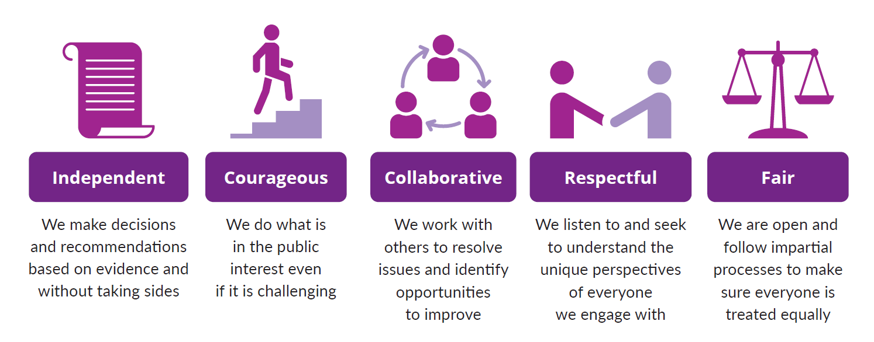

# 5. NHPO polices

5.1 NHPO staff are required to familiarise themselves and act in accordance with NHPO policies. These policies are:

* conflict of interest policy
* media policy
* privacy policy
* procurement policy.

# 6. Applicable legislation

6.1 NHPO staff must familiarise themselves and act in accordance with the following legislation:

* *Ombudsman Act 1976* (Cwlth)
* *Privacy Act 1988* (Cwlth)
* *Freedom of Information Act 1982* (Cwlth)
* Health Practitioner Regulation National Law (as modified by the Health Practitioner Regulation National Law Regulation 2018).

# 7. Compliance

7.1 Depending on the circumstances, not complying with this code may constitute a breach of employment or contractual obligations, misconduct, sexual harassment, discrimination, or some other contravention of the law.

7.2 The code relates to both performance and conduct. NHPO staff who fail to comply with the code may face disciplinary action, including possible termination of their employment or engagement.

7.3 If a NHPO staff member notices inappropriate or unlawful content or behaviour in breach of this code, the staff member should alert the Ombudsman and Commissioner.

7.4 If someone is dissatisfied with the conduct or performance of an NHPO staff member, a complaint can be made in writing to the Ombudsman and Commissioner via [complaints@nhpo.gov.au](mailto:complaints@nhpo.gov.au). Any complaint will be managed in accordance with the principle of procedural fairness.

# 8. Review

8.1 The code is reviewed every three years by the Ombudsman and Commissioner in consultation with staff and relevant stakeholders.

To receive this document in another format phone 1300 795 265, using the National Relay Service 13 36 77 if required, or [email](mailto:complaints@nhpo.gov.au) <complaints@nhpo.gov.au>.

Authorised and published by the National Health Practitioner Ombudsman,   
50 Lonsdale St, Melbourne.

GPO Box 2630

Melbourne VIC 3001

Phone 1300 795 265

[Email National Health Practitioner Ombudsman](mailto:complaints@nhpo.gov.au) <complaints@nhpo.gov.au>

[National Health Practitioner Ombudsman website](https://nhpo.gov.au) <https://nhpo.gov.au>

© National Health Practitioner Ombudsman, Australia, October 2020.