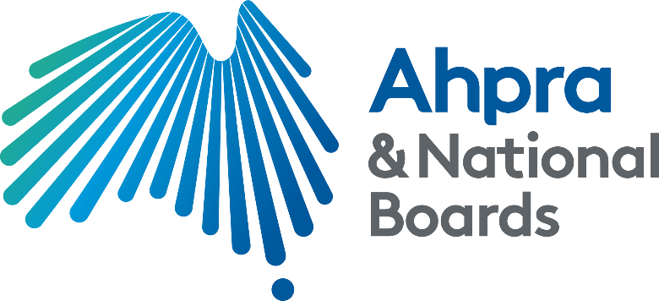



Terms of Reference

Review of the Ahpra’s framework for identifying and dealing with vexatious notifications

To take effect from: 20 June 2022

Preamble

In early December 2020 the Australian Health Practitioner Regulation Agency (Ahpra) published a new framework to support the identification and management of potentially vexatious notifications.

The [*Framework for identifying and dealing with vexatious notifications*](https://www.ahpra.gov.au/Notifications/How-we-manage-concerns/Vexatious-notifications.aspx) (the Framework) was developed from recommendations outlined in the *Review of confidentiality safeguards for people making notifications about health practitioners* (Confidentiality Review)*.* It incorporated findings of the 2018 research report (Research Report’), *Reducing, identifying and managing vexatious complaints: Summary report of a literature review prepared for the Australian Health Practitioner Regulation Agency.*

Ahpra has invited National Health Practitioner Ombudsman (NHPO), Ms Richelle McCausland, to complete an independent review of the implementation of the Framework to consider, and where necessary make recommendations regarding, Ahpra’s approach to identifying and managing vexatious notifications.

**Scope of the review**

The review has two parts.

Part 1 addresses the Framework and written internal guidance.

Part 2 addresses internal practice to assess the success of implementation.

**Part 1: The NHPO will consider the Framework and the internal artefacts produced by Ahpra to explain how and when to apply the Framework. This will include considering:**

1. Whether the Framework adequately reflects findings of the Research Report and issues raised in the Confidentiality Review.
2. Whether the internal artefacts adequately describe actions expected of staff to successfully adopt the Framework.
3. Any recommendations about changes to the Framework or artefacts.

**Part 2: The NHPO will consider the way in which the Framework and artefacts are applied in practice. This will include considering:**

1. Whether the implementation of the Framework and the artefacts has been successful and if there have been any unintended consequences.
2. Whether the Framework is being appropriately and consistently applied by Ahpra notifications staff.
3. Whether any actions taken in response to a notification identified as vexatious have been adequate and in accordance with the Health Practitioner Regulation National Law.
4. Whether there are any gaps in practice and whether the gaps are due to an inadequacy in the Framework and artefacts or another reason.
5. Any recommendations about further actions to be undertaken by Ahpra to enable more rapid and robust identification and management of potentially vexatious notifications.

**Terms of the review**

1. The NHPO will undertake the review under its investigative powers.
2. The NHPO will be provided with all reasonable assistance from Ahpra to undertake the review.
3. The NHPO will undertake targeted consultation with relevant health practitioners, individuals and organisations as part of the review.
4. The NHPO will document all activities and findings from the review. A report of the review, including the scope, method, findings and recommendations will be submitted to Ahpra’s CEO on completion of the review.
5. The report of the review, and Ahpra’s response, will be jointly published.
6. The NHPO can report at any time to any level of Ahpra’s leadership team as deemed appropriate. Ahpra’s CEO, Executive Director Regulatory Operations or National Director Notifications can request an interim update of the review at any time.
7. Document or information requests from the NHPO to Ahpra must be responded to within 5 business days. Any non-compliance with this timeframe will be escalated by the NHPO to Ahpra’s National Director Notifications who will be responsible for adequate follow up activities.
8. The NHPO, in consultation with Ahpra’s National Director Notifications, can nominate staff members from the office of the NHPO or Ahpra to assist in the review.

**Timeframes**

The NHPO and Ahpra have agreed that a draft report will be submitted to Ahpra for consultation by the end of 2022. The final report will be completed in early 2023.

**Governance**

A reference group for the review will be established and meet as required, comprising of Ahpra’s National Notifications Leadership Group.

The NHPO will provide progress reports that will enable the reference group to maintain any reporting obligations.

**Key terms and roles**

**Reviewer**: NHPO, Richelle McCausland

**AHPRA CEO**: Ahpra Chief Executive Officer, Martin Fletcher

**EDRO**: Ahpra Executive Director Regulatory Operations, Kym Ayscough

**NDN**: Ahpra National Director Notifications, Matthew Hardy

**Ahpra staff**: any person currently employed at the Australian Health Practitioner Regulation Agency

**NHPO staff**: any person currently employed at the National Health Practitioner Ombudsman