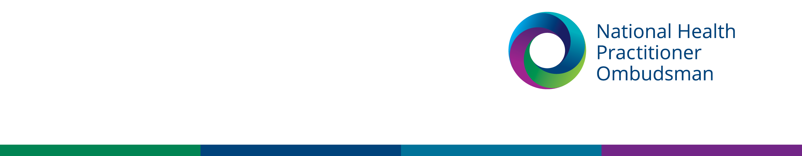

|  |
| --- |
| Media release |
| 22 November 2022 |

**National Health Practitioner Ombudsman receives record number of complaints about national health practitioner regulators in 2021–22**

The office of the National Health Practitioner Ombudsman (NHPO)’s recently released [annual report](https://www.nhpo.gov.au/annual-report-2021-22) reveals it received a record 1,593 approaches in 2021–22, a 65 per cent increase from last financial year. This included 823 complaints to the National Health Practitioner Ombudsman, a 42 per cent increase from 2020–21.

Ombudsman Richelle McCausland said that the increase appears to mostly have been driven by people raising concerns about regulatory responses to the pandemic, particularly the Australian Health Practitioner Regulation Agency (Ahpra) and the National Health Practitioner Boards’ (the Boards) statements regarding health practitioners’ obligations around vaccination.

“My office is seeing the ongoing effects of the pandemic on community members and health practitioners, and we remain focussed on assisting with concerns about how Ahpra and the Boards have handled matters, including notifications and registration matters,” the Ombudsman said.

The NHPO estimates that it received 327 complaints to the Ombudsman and 190 enquiries related to the COVID-19 pandemic in 2021–22.

The Ombudsman said that the increase in approaches presented her office’s greatest opportunity to identify and address issues to create fair and positive change in health practitioner regulation. Some of the office’s most significant contributions in 2021–22 included:

* joining the expert panel for the independent review into the regulation of health practitioners in cosmetic surgery
* initiating a review into the implementation of Ahpra’s framework for identifying and managing vexatious notifications made about health practitioners.

The Ombudsman said that Ahpra had taken steps to improve its customer service in the financial year, including updating its service charter outlining expectations for engagement. However, she said areas for improvement are evident, and that her office would continue to particularly monitor issues related to:

* Ahpra’s delays in investigating notifications after immediate action had been taken against practitioners
* the fairness of Ahpra and the Boards’ application of the English Language Skills Registration Standard
* inadvertent disclosure of information about confidential notifiers.

The Ombudsman said she anticipates complaints will continue to rise in the new year, as her office expects to receive new powers to consider complaints related to accreditation authorities in the National Registration and Accreditation Scheme for health practitioners.

The NHPO provides a free and independent complaint service. Anyone can make a complaint to the office by calling 1300 795 265, emailing [complaints@nhpo.gov.au](mailto:complaints@nhpo.gov.au) or visiting www.nhpo.gov.au.

**For more information, please contact our media team at** [**media@nhpo.gov.au**](mailto:media@nhpo.gov.au)**.**