

Service Charter
29 April 2026
This document sets out what we expect when people engage with us and the standards of service you can expect from us.

What we do
The office of the National Health Practitioner Ombudsman (NHPO) champions fairness by taking every complaint seriously and shining a light on systemic issues to effect positive change. We oversee entities in the National Registration and Accreditation Scheme (the National Scheme), including the Australian Health Practitioner Regulation Agency (Ahpra), the 15 National Boards, accreditation authorities and specialist medical colleges.
Please contact us by phone, email or post, or visit our website to find out more about our complaint handling and Freedom of Information (FOI) review processes.
Telephone: 1300 795 265 (interpreter services: 131 450)
Email: <complaints@nhpo.gov.au>
Mail: GPO Box 2630, Melbourne, VIC 3001
Website: <www.nhpo.gov.au>.

Who can access our services
Our free and independent services are available to all, including the public and health practitioners.
We accept confidential and anonymous complaints. These complaints can be more challenging for us to progress, so we request that you call us first to discuss how we handle personal information.

What we expect from you
- Be polite and treat our staff with courtesy and respect. This includes not making abusive, aggressive, threatening, discriminatory or offensive remarks, including about an individual’s age, gender, sexual preference, religion, race, ethnicity, nationality or disability.
- Clearly identify what issues you would like addressed and the outcome you are seeking.
- Respond to requests for information in a timely way.
- Provide honest and accurate information.
- Inform the staff member handling your matter if you need to correct or update any information provided (including contact information) or if you wish to withdraw your complaint or application.
Please remember to let the staff member handling your matter know if you need any assistance to participate in our complaint or FOI review processes. For example, an interpreter or translator.
Unreasonable conduct may result in us placing limitations or conditions on your ability to communicate with staff or access certain services. We do not tolerate any abuse, aggression, threats or violence directed towards our staff. Any conduct of this kind may result in us deciding to stop engaging with you. If the conduct is of a criminal nature, it will be reported to police. Other legal action may also be considered.

What to expect from us
We are guided by and committed to our values. Our values shape how we interact with you and how we expect you to engage with us.

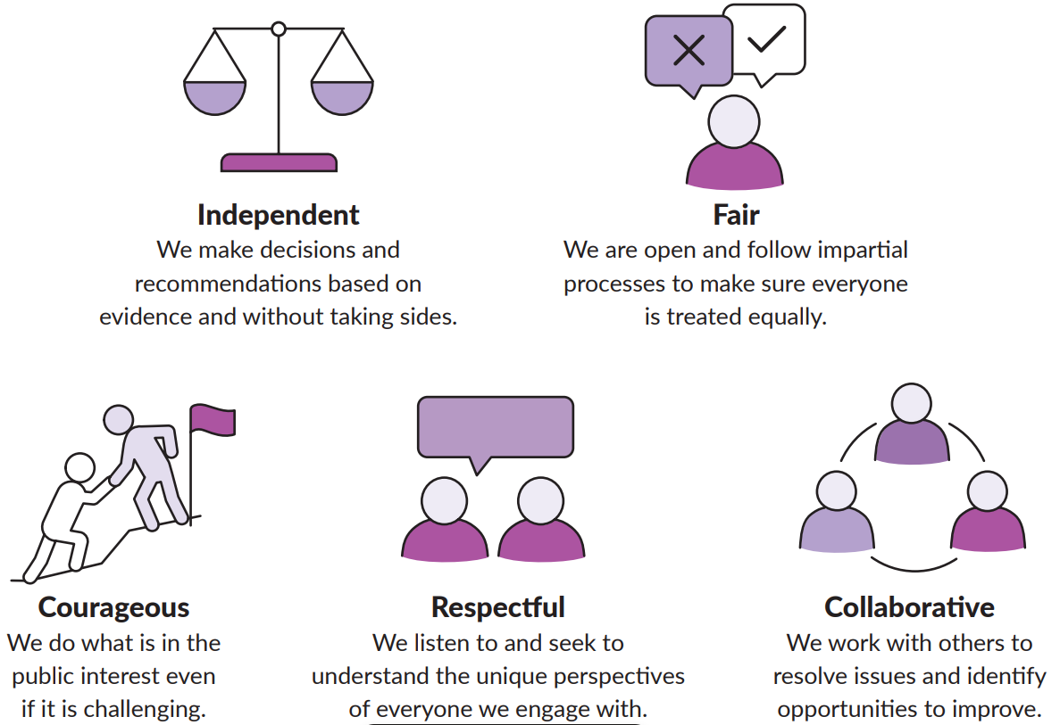

Value 1: We are independent
What we will do | We will provide our services to anyone who needs them.  We will provide our services for free.  We will thoroughly consider all the information provided to us without taking sides.  We will record and analyse information gathered through our services to achieve our purpose.  We will publicly share information about our work and be accountable for our performance.
What we will not do | We cannot provide legal advice or act as an advocate.  When we receive a complaint to the Ombudsman, we cannot force Ahpra, a National Board, an accreditation authority or a specialist medical college to change its decision.
Value 2: We are fair
What we will do | We will make it easy to access our services and to understand our processes.  We will explain which issues we will consider and which issues are out of our scope.  We will provide clear reasons for our decisions at every stage of the complaint and FOI review process.
What we will not do | We will not make an unfavourable comment or decision about an agency without providing them with an opportunity to respond.  We will not finalise an investigation or final FOI review determination without providing the parties with an opportunity to respond to our proposed decision or preliminary view.
Value 3: We are courageous
What we will do | We will use our statutory powers responsibly and when required.  We will respond in a fair and proportionate way to identified issues in line with our publicly available policies and the law.  We will make suggestions or recommendations for improvement to address identified systemic issues requiring remedy.
What we will not do | We will not compromise our independence or impartiality.  We will not let challenging subject matter prevent us from listening to and considering all perspectives.
Value 4: We are respectful
What we will do | We will treat everyone with courtesy and respect.  We will assist people of all backgrounds, genders, sexualities, cultures, bodies and abilities.  We will carefully consider concerns and clarify whether we have understood the issues raised.  We will use our training to provide professional and empathetic services.  We will respond to unreasonable conduct reasonably and proportionately.
What we will not do | We will not share confidential or personal information for a reason other than the purpose it was collected for, unless consent is given or it is required by law.  We will not tolerate any abusive, aggressive, threatening, discriminatory or offensive remarks, including about an individual’s age, gender, sexual preference, religion, race, ethnicity, nationality or disability. This conduct may result in our placing limitations or conditions on access to certain services to support staff health and safety.
Value 5: We are collaborative
What we will do | We will clearly communicate how we can assist and what the next steps are for each matter.  We will provide regular updates about a complaint or application.  We will allow reasonable contact with the staff member managing your complaint or application.  We will answer questions and queries to the best of our abilities.  We will provide referral information wherever possible to help ensure the most appropriate body considers the concerns raised.
What we will not do | We will not consider matters outside our jurisdiction. We cannot accept complaints about the Health Care Complaints Commissioner or the Health Professionals Council Authority in New South Wales, or the Office of the Health Ombudsman in Queensland.  We will not restrict access to our services unless it is a necessary response to unreasonable conduct. We will not leave complainants without any means of contacting us unless there is a significant risk posed to the health or safety of our staff or another individual.

When you’ll hear from us
We aim to address your matter as quickly as possible while ensuring it is comprehensively considered. We will keep you informed of your matter’s progress based on the following timeliness targets.
Find out more about what to expect on our website: <www.nhpo.gov.au/what-to-expect>
Type of contact | Timeframe
We acknowledge your matter has been received | 3 working days
The case officer managing your matter contacts you | 10 working days of your matter being received
Your complaint or application is finalised | Approximately 3 to 6 months
Your more complex complaint or application is finalised | Approximately 6 to 12 months
For ongoing complaints and applications | We will contact you
We provide a progress update (if this information has not been provided more recently) | Every 6 weeks
We return your phone call | 3 working days
We acknowledge or respond to your written communication | 10 working days

Feedback and review of our decisions
We welcome feedback about our service delivery and applications for internal reviews of decisions. We see these as opportunities to address concerns, provide a better explanation of a decision or action, and improve our services for others.
We request you first contact the staff member who managed your matter to discuss any concerns. If this does not resolve the matter, you can contact us to:
- provide feedback on our service delivery <www.nhpo.gov.au/feedback-about-our-services>
- apply for an internal review: <www.nhpo.gov.au/review-of-our-decisions>.

To receive this document in another format phone 1300 795 265, using the National Relay Service 13 36 77 if required, or email <complaints@nhpo.gov.au>.
Authorised and published by the National Health Practitioner Ombudsman.
© National Health Practitioner Ombudsman, Australia, April 2026.

