

Early resolution transfers
Frequently asked questions

Why do we transfer complaints?
We generally suggest an early resolution transfer if you have not first made a complaint about your concerns to the organisation you are complaining about.
The transfer process gives the organisation the opportunity to respond to and address your concerns directly.
For example, people with an active notification or registration matter sometimes contact us without first making a complaint to Ahpra. These complainants often raise concerns about delays associated with finalising a notification or a registration application. For complaints like these, we have found that people often receive an update, and sometimes the registration process is sped up, through the transfer process.
You can read Ahpra’s Complaints Handling Policy and Procedure on its website: <www.ahpra.gov.au/About-AHPRA/Complaints.aspx>.

What is the transfer process?
There are 3 main steps in the transfer process.
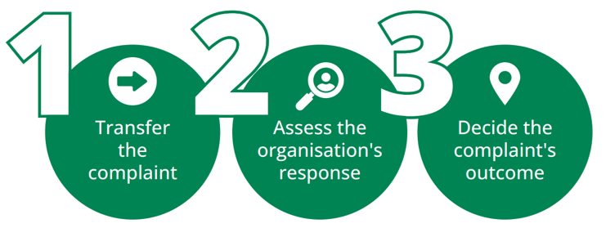

Step 1: we transfer your complaint
We contact you to explain why we believe a transfer is the best way to address your concerns. We then request your consent (either written or over the phone) to transfer your complaint.
If you provide consent, we contact the organisation directly to transfer the complaint. The complaint remains open with our office while the organisation responds to it.
The organisation has 2 business days after the date it receives the complaint from our office to acknowledge receipt.

Step 2: we assess the organisation’s response
The organisation is required to respond in full to the complaint within 20 business days.
Once you receive the organisation’s response, we assess whether the response is fair and reasonable.
We will ask for your perspective on the response before we make a decision.

Step 3: we decide on the complaint’s outcome
We let you know the outcome of the early resolution transfer process with a detailed explanation of why this decision was made.
We have found that most complaints are resolved through this process. This could include, for example, the organisation remedying the issues raised or agreeing to a particular action or process improvement. However, we may make preliminary inquiries or start an investigation if our office is not satisfied with the organisation’s response and we believe further action is necessary. For more information about our other complaint processes, visit our website <www.nhpo.gov.au>.

Will you advocate for me when you transfer my complaint?
We are independent and impartial, which means we do not advocate for you or the organisation you’re complaining about. Instead, we make decisions without taking sides and by considering all information available to us. This means we may come to a different decision about the appropriate response to your complaint than you and/or the organisation you’re complaining about.

What if I am not happy with the organisation’s response?
We will consider any issues or concerns you raise with us about the organisation’s response. We encourage you to contact the person managing your matter if you have any questions or concerns.
It is important to remember that our assessment of the response may not always be the same as yours. Your satisfaction with the complaint response is a factor considered during our assessment, but it is not the deciding factor.

What if I’m not happy with my complaint outcome?
If you are not happy with your complaint outcome, please contact the person who managed your complaint to let them know why. This gives us the chance to address your concerns or provide a further explanation of our decision.
If this does not resolve your concerns, we accept feedback about our service delivery and you can apply for an internal review of our decision about your complaint. All internal reviews are managed by a staff member who has not previously made a decision in relation to the complaint being reviewed. For more information about how to raise concerns, visit our website: www.nhpo.gov.au.
To receive this publication in an accessible format, please phone 1300 795 265, using the National Relay Service 13 36 77 if required, or email complaints@nhpo.gov.au.
Authorised and published by the National Health Practitioner Ombudsman.
© National Health Practitioner Ombudsman, June 2026.

